1.0. Introduction

* 1. Research problem

Aviation delays and disruptions can cause many inconveniences for people and society more generally. The global delay cost in 2014 after examining 130 airlines worldwide was 25 billion US dollars (Carbone, 2015). Over the last 16 years the number of passengers boarded by the global airline industry have increased from 1994 million in 2004 to an expectation of 4723 million in 2020 before the coronavirus epidemic occurred. This is an increase of 137% since 2004 (Mazareanu, 2020). The passenger demand growth has led to an increase of aviation delays.

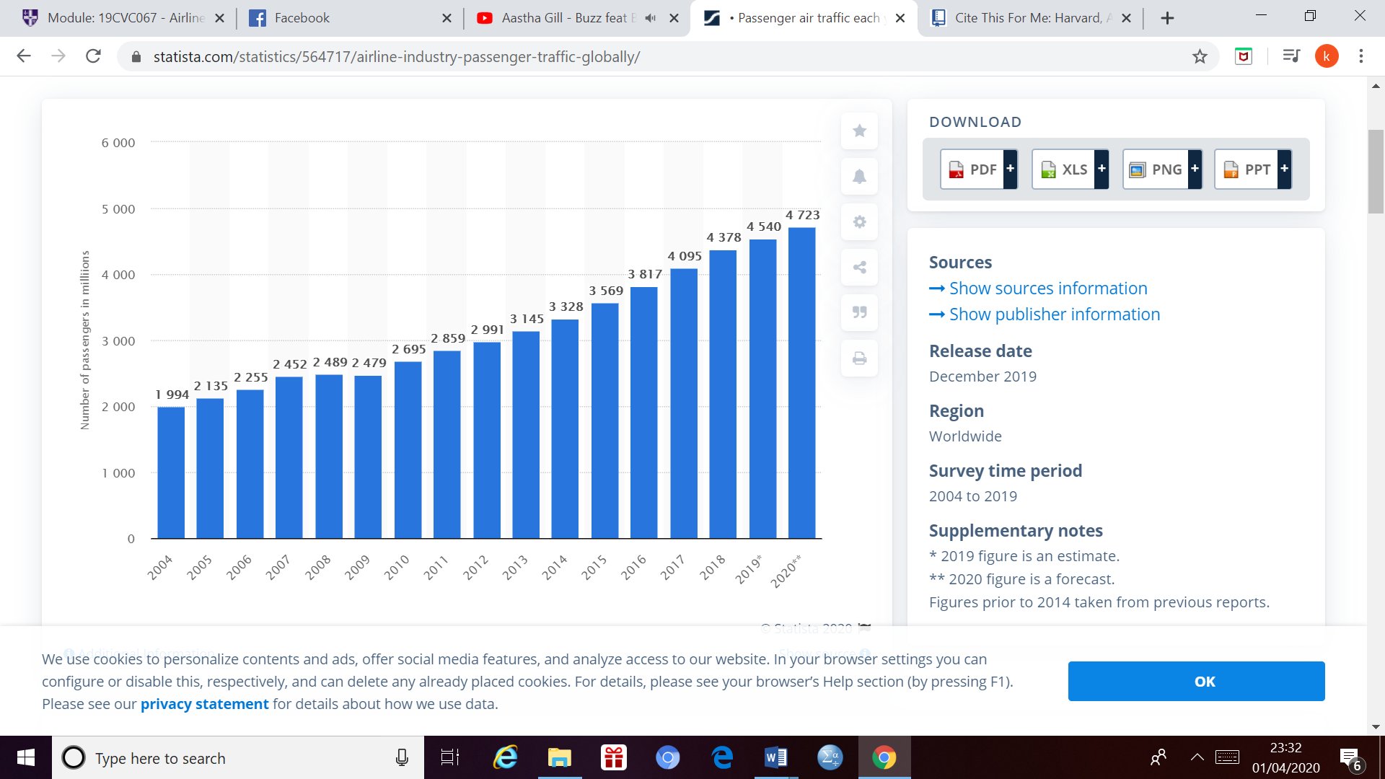

Figure 1 – passengers boarded globally each year from 2004 to 2019 with an estimated value in 2020 (Mazareanu, 2020)

In Europe as of 2018 the 15-minute arrival punctuality was 75.8% in 2018. The network experienced the busiest day ever on the 7th of September with 37,088 flights. The number of flights per day gradually increased from January to June before levelling off and decreasing at a quick rate from September to December. In 2018 5.3% of flights which had delays of 60 minutes or greater. During 2018 the greatest amount of flights which had a delay of over 60 minutes was during July (Walker, 2018).

The average delay per flight was 14.7 minutes in 2018. The average delay per delayed departure was 30.5 minutes per flight in 2018. The average delay per flight on arrival was 13.8 minutes per flight. The average delay per delayed flight was 32.3 minutes per flight in 2018 (Walker, 2018).

According to (Mulligan, 2019) a single minute of delay is estimated to cost the European economy around 100 euros, this includes everything from extra fuel burn to compensation for passengers. Eurocontrol estimates there to be a cost of 17.6 billion euros to the economy due to the delays in 2018. The passengers may also miss there connecting flights due to the delays which would mean that it would create a bad image for the airlines also, which may affect the passengers choice of airlines in the future as well their recommendation of airlines to other people. Apart from this it can also harm the environment by the extra emission’s such as Carbon Dioxide (SOx) and Nitrogen Dioxide (NOx) released due to the delays and extra time spent on the ground. On a large scale these emissions can cause there to be global warming hence rising sea levels which lead to more floods and hurricanes. Apart from this as the surface temperature rises there are more droughts and irregular temperature patterns. Also, the higher levels of Carbon dioxide can cause respiratory problems such as Asthma etc.

Overall the passenger demand has increased over the years which had led to a higher amount of delays hence there have negative externalities in terms of costs and emissions which would damage the environment and lead to there being drastic issue’s such as health problems and extreme weather conditions such as hurricane’s etc.

According to the Civil Aviation Authority, the total amount of terminal and transit passengers as of 2018 at Guernsey Airport were 837,615. This is much less compared to major mainland English Airports as you would expect such as Heathrow which had 80,124,537 (Hutton, 2018). FAA have categorised airports into the following categories shown below in the table.

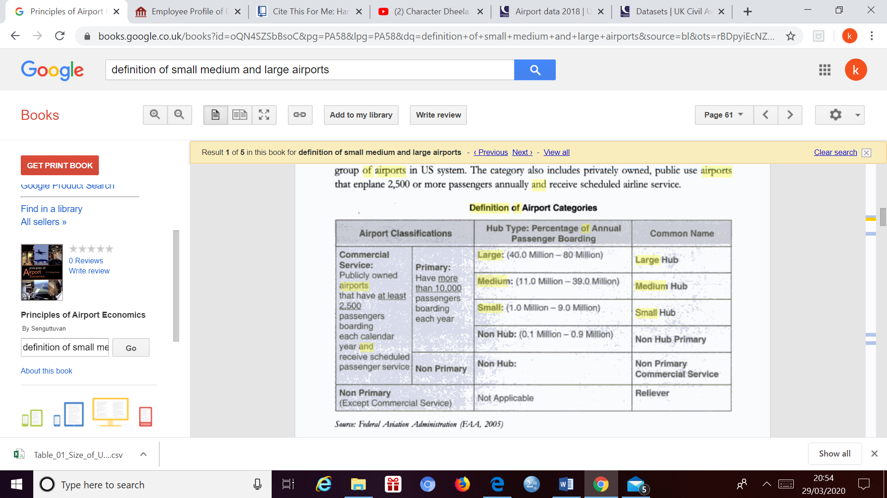

Table 1 – definition of airport categories (Senguttuvan, 2007)

According to the table above Guernsey Airport is a primary commercial airport but is a non -hub airport as the annual passengers boarding are between 0.1 million and 0.9 million with 837,615 whereas Heathrow Airport is a large hub airport as we already expect. There has not been much research regarding delays at airports which are smaller in size and it would be interesting to see how it would vary from airports which are larger in terms of size and number of passengers (Senguttuvan, 2007). The data above maybe useful as a reference point to compare Aurigny Airlines delays to.

1.2. Research aim and objectives

Aim: To investigate the causes of aviation delays and possible mitigation methods.

Objectives:

1) To identify factors which are affecting aviation delays

2) To examine factors affecting delays at regional airports with the use of data from Aurigny Airlines.

3) To provide solutions to policy makers and practitioners for mitigating air traffic delays

1.3 Structure of project

My project will have 6 chapters. In this chapter I looked at how the amount of delays may have varied from previous years due to the change of policies and the external environment as well as the impact delays can have on a large scale. In the second chapter I analysed a wide range of literature along with previous research carried out on flight delays to analyse the various causes of delays at a range of airports and mainly larger in size relative to Guernsey Airport. I also looked at research carried out previously for solutions to mitigate aviation delays. In chapter 3 I describe my methodology in which I give some contextual information regarding Aurigny Airlines and describe my dataset as well as how I manipulated the data to help analyse the delays more effectively along with the analysis process. In chapter 4 I portrayed my findings and results from my analysis. In chapter 5 I discussed my results and the possible reasons for the findings. Finally, in chapter 6 I summarised my project in the conclusion.

2.0 Factors affecting aviation delays

There has been much research and scholarly work on Aviation delays and the factors which affect them. In this chapter we will analyse literature to understand which factors affect delays and to what extent the factors affect them. This chapter has 7 main sections.

Causes of delays can be Internal (Airline, airport or en-route) or external (weather, miscellaneous) (ATEŞ, KAFALI and ÇELİKTAŞ, 2018).

The first section looks at airline-related factors, the second section focuses on airport- related delays, In the third section we look at En-route delays, in the fourth section we look at weather related delays followed by a section regarding ideas for potential solutions and various strategies to mitigate aviation delays. Lastly there will be a section to evaluate this chapter and identify where there is a research gap.

2.1. Airline related factors

Airline- related delays are delays under the influence of the airline. Some examples of these types of delays are delays due to baggage and luggage, aircraft damage and operations computer failure and lastly flight operations (ATEŞ, KAFALI and ÇELİKTAŞ, 2018). Airline related factors can include operational factors and technical problems. The data above is the average values of delays of each type in the summer period from 2008-2014. Airline related factors can include operational factors and technical problems. The data below is the average values of delays of each type in the summer period from 2008-2014. According to (Vaaben and Larsen, 2015) most of the primary delays (41.8%) were caused by factors related to the airline itself, this including technical problems, baggage delays and other operational reasons.

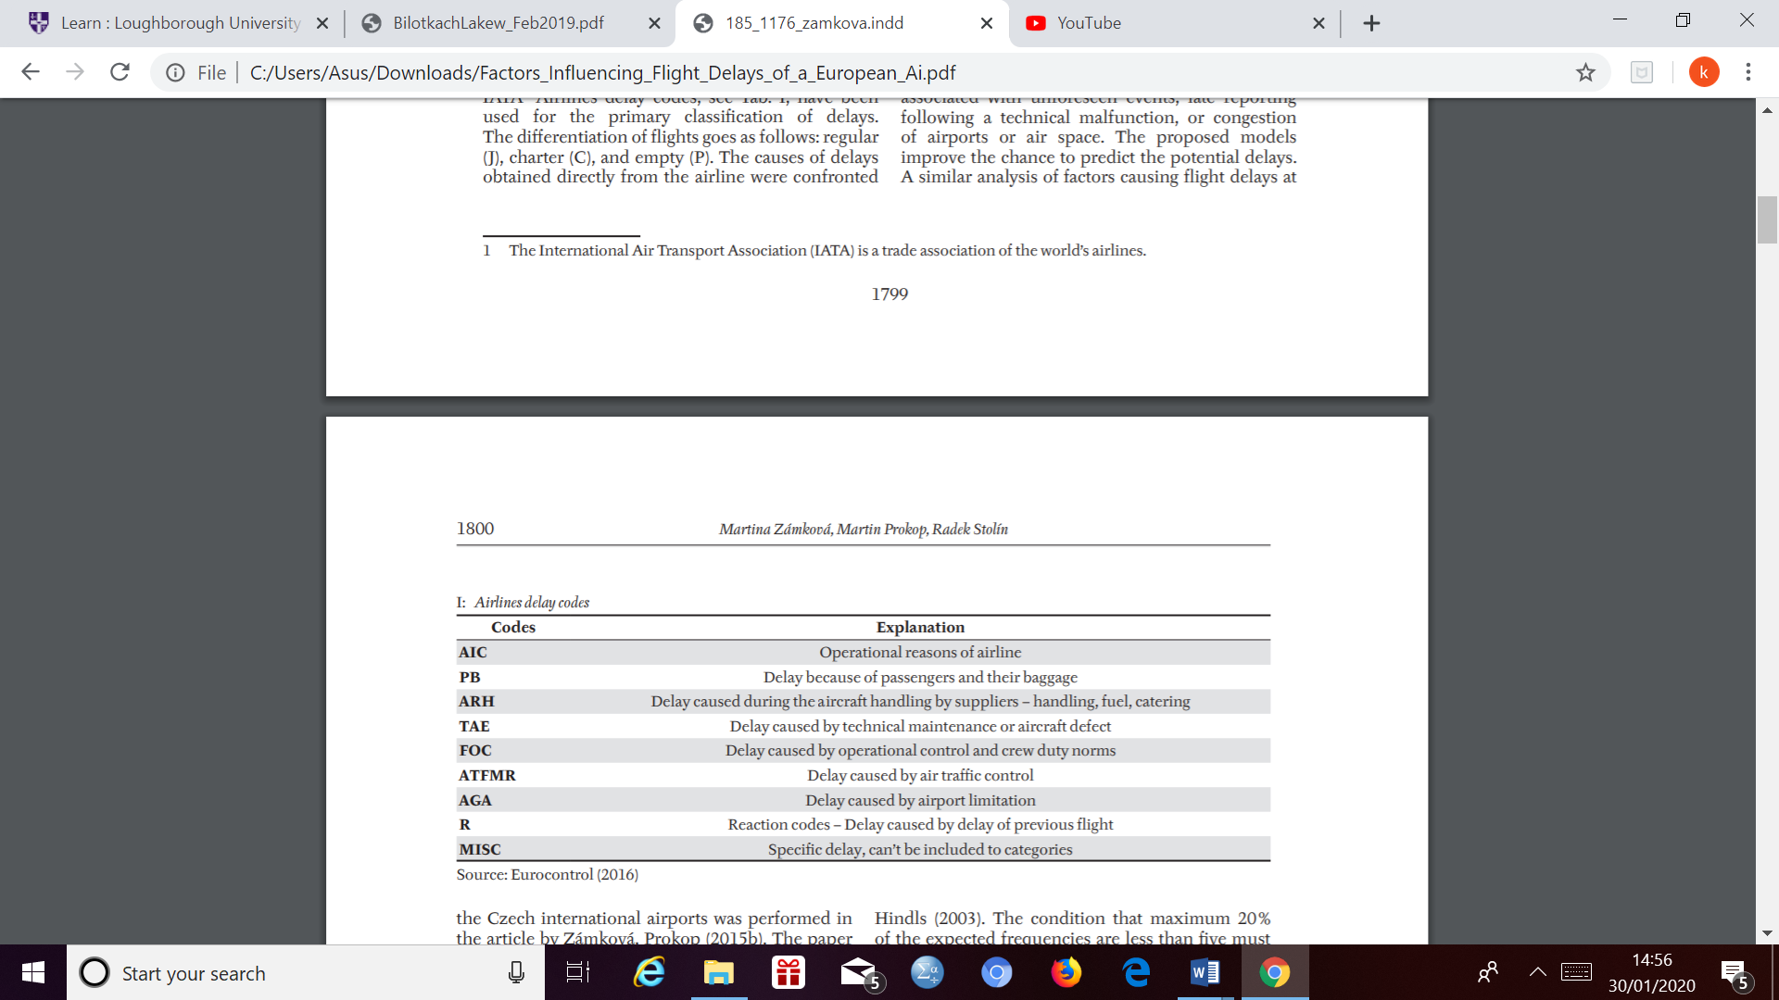

Figure 2 – Codes for various types of delays (Zámková, Prokop and Stolín, 2017)

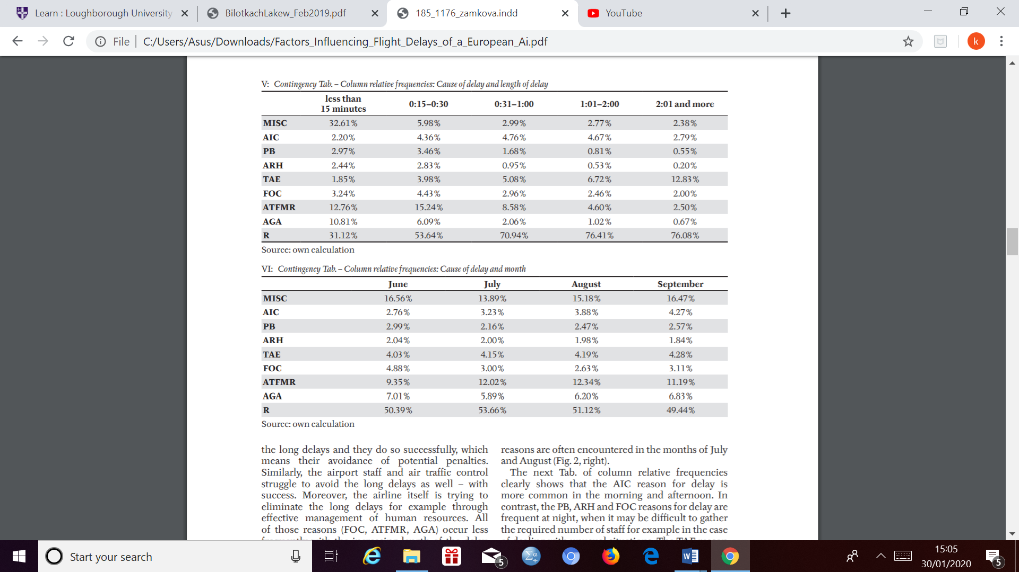

Figure 3 - cause of delays and length of delay (Zámková, Prokop and Stolín, 2017)



Figure 4- causes of delay and month (Zámková, Prokop and Stolín, 2017)

2.1.1. Baggage and luggage related delays

According to (Yazdi, Dutta and Steven, 2017) The implementation of baggage fee’s leads to improvements in airline on time performance as measured through late flights. The typical airline that implemented fee’s policy lead to there being a 4% reduction in passenger demand. This led to there being a reduction of 6% of late flights. An example of this at Atlanta International Airport (ATL), where according to (Research Board, 2020) the major challenges from the volume of bags and passengers being handled. International movements at ATL typically call for approximately 23,000 arriving bags per day. This would amount to an hourly peak of more than 1,100 bags on average with peak that could approach 1,500 bags depending on the number of wide-bodied aircrafts. Baggage rechecks connection issue Is based on connection times and accommodating the massive volumes of passengers. Currently 80 minutes’ is the standard for international-domestic flights connection time’s at ATL. However due to 12 wide- bodied aircrafts currently arrive between 3:30 and 5:00 pm, peak baggage volumes can result in up to 20% of international bags missing connection.

Lastly according to (Yazdi, Dutta and Steven, 2017) if the origin or destination airport or both are hub airports, baggage fee’s will have less of an impact in terms of reduction of late flights. The potential reason for this would be the complexity of operations at hub airports in terms of the processing of bag screen, matching and loading are more complicated due to several connecting flights and also there being a high volume of people.

2.1.2. Aircraft damage and operations

The incidence of operational reasons of airline contributing to delays (AIC) and delays due to technical maintenance and aircraft defect (TAE) is growing during the summer season, frequent technical deficiencies occurring during the summer season may be due to the heavy usage of aircrafts during this period of the year (Zámková, Prokop and Stolín, 2017). According to (Aviation, 2020) Unscheduled maintenance accounts for around half of an airline’s delays. Technical problems along with maintenance of aircraft typically require a longer period of time that is why they more frequently result in long-lasting delays. Delayed previous flights often significantly interfere with the flight plan and cause longer dela and technical aircraft maintenance can cause over 1-hour long delays (Zámková, Prokop and Stolín, 2017). According to (Hussin, Ismail and Mustapa, 2016) when FOD has caused damage to the aircraft, the aircraft is normally parked at the designated area to let maintenance personnel to inspect and repair it as required. The aircraft will only return to service once the damage has been repaired. If significant repair has to be conducted, the aircraft will be on the ground for a long time and this causes flight cancellations. The cost of aircraft delay and cancellation fees are really high, hence gives big impact to airport and airline operators. A study has identified that average cost of flight delays is $40 per minute per aircraft, it would include delays at gate waiting time, taxi out time, airborne – time and taxi in time. Also, data from two large European airport showed that their runways were closed due to FOD and wildlife for an average of 200-400 minutes per month (Hussin, Ismail and Mustapa, 2016).

2.1.3. flight operations

Airline operational reasons (AIC) for delays is more common during the morning and afternoon whereas delays due to passenger baggage (PB), aircraft handling by suppliers (handling, fuel and catering) (ARH) and operational control and crew duty norms (FOC) are frequent at night as it would be difficult to gather the required number of staff for example in the case of dealing with unusual situations (Zámková, Prokop and Stolín, 2017). Overall crew scheduling issue’s account for 3% of all global flight delays which equates to a loss of $3.6 billion-dollar loss (Aviation, 2020).

Delays may also be attributed towards airline operations procedures, an example of this if an airline operate by the hub and spoke system. The advantage this can provide to airline’s is that they allow the passengers, aircraft and crew to be re-routed to various destinations. They also provide airline’s the opportunity to consolidate passengers into some flights while cancelling others. However, this can mean airport will experience arrival and departure rushes with very small resource utilization in the interim periods (R. Mueller* and B. Chatterji, 2002).

2.2. Airport related delays

Airport related delays are delays related to congestion at the airport. There are many forms of congestion, some congestion is such that they cause there to be an inability of more than one aircraft to move out of some parking cul -de – sacs, this will affect start up hence departure. Other airport congestion issues, such as lack of parking spaces, excessive arrival demand, or taxiway problems may result in arrival delays, or possible delays to aircraft which have not yet departed from the previous airport (ATEŞ, KAFALI and ÇELİKTAŞ, 2018).

Air traffic is constantly growing and to prove this fact there was a rise of 4.3% in the number of flights in Europe in 2017 compared to 2016. This corresponds to an additional 1191 flights per day on average and 20.4% of the flights in 2017 experienced an arrival delay of 15 minutes or more an increase from 11.3 minutes in 2016. The principle cause of delays is when there is a demand- capacity imbalance (Lambelho et al., 2020). According to (Research Board, 2020) Congestion is the second most common cause of flight delays associated with air traffic control causing 12% of all departure and en-route delays as of 1998 and 1999 of all. Airport limitations is the most common cause of delays during the morning and night. At this time various restrictions apply at many airports and impede the traffic and therefore cause of delays (Zámková, Prokop and Stolín, 2017). Also, according to (Vaaben and Larsen, 2015) 24% of all flights in Europe were delayed by more than 15 minutes hence faced disruption and as of 2010 the airspace being congested was growing as a factor to increase uncertainty elements. In comparison to 2010 the amount of delays of 15 minutes or more in 2017 were lower within Europe.

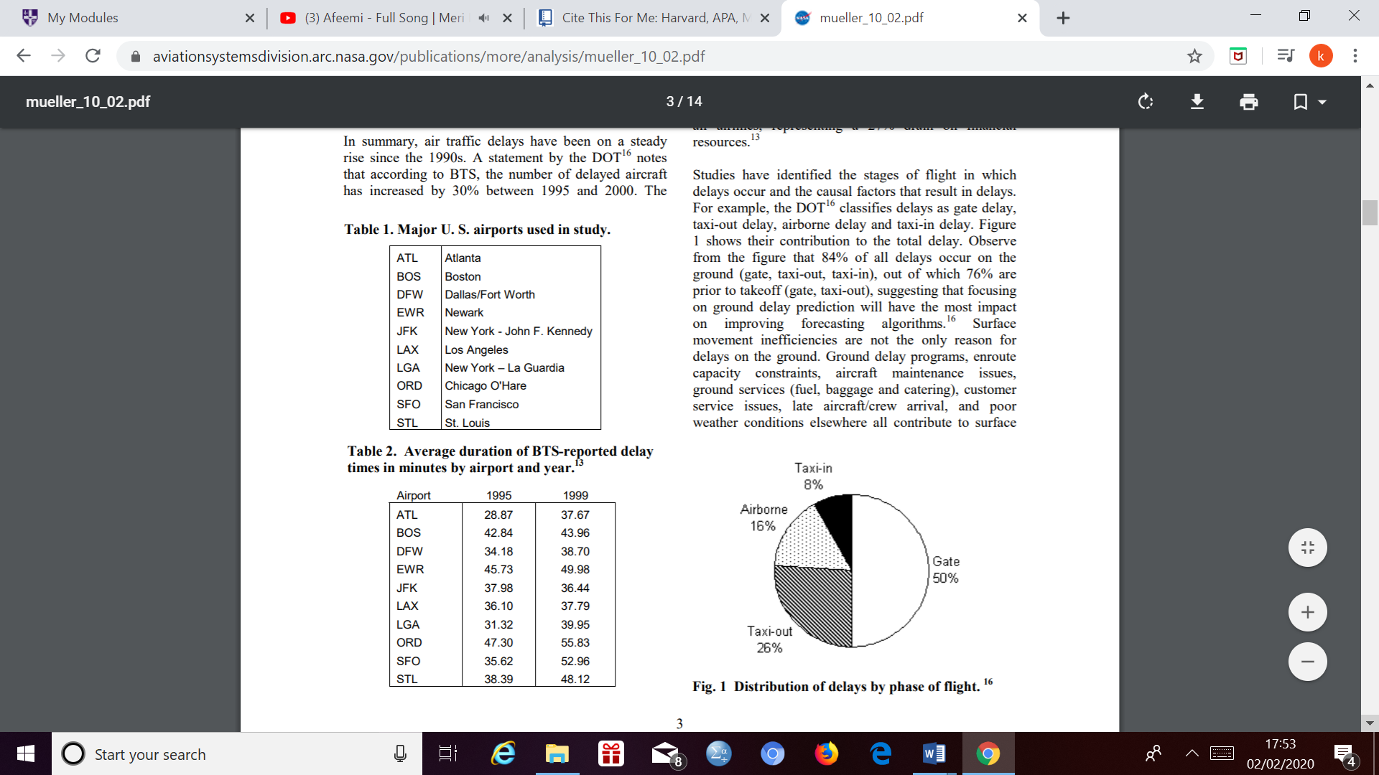

Figure 5 – distribution of delays by flight phase (R. Mueller* and B. Chatterji, 2002)

Figure 4 above shows that 84% of all delays occur on the ground (gate, taxi out and taxi in) and 76% of these delays take place before take-off. This shows that there should be focus on improving predictions for ground delays. As stated earlier the major causes of ground delays include surface movement inefficiencies, en-route capacity constraints, aircraft maintenance issue’s and late aircraft arrival etc (R. Mueller* and B. Chatterji, 2002).

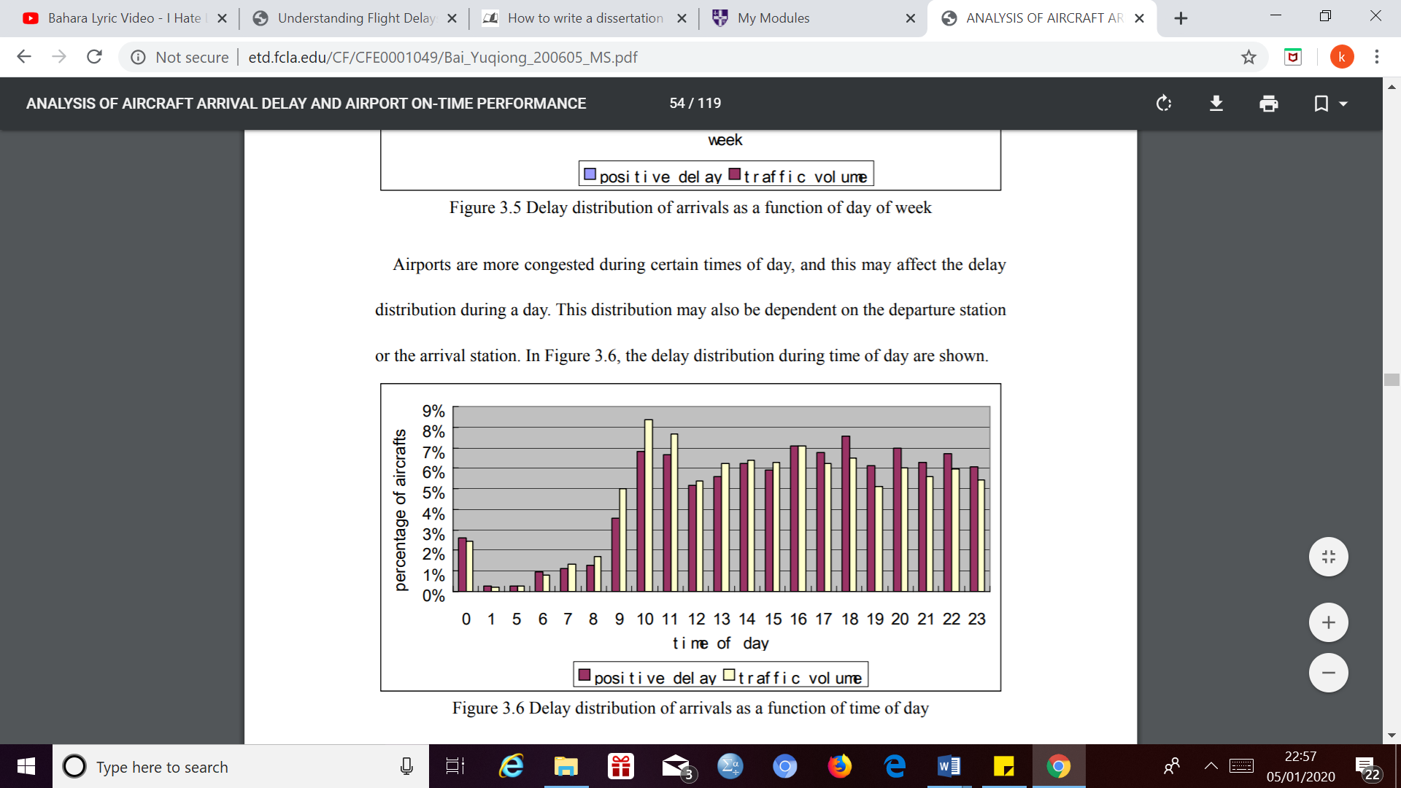

Figure 6- traffic volume and delay data of MCO Airport (Orlando) as of 2002 and 2003 (BAI, 2004).

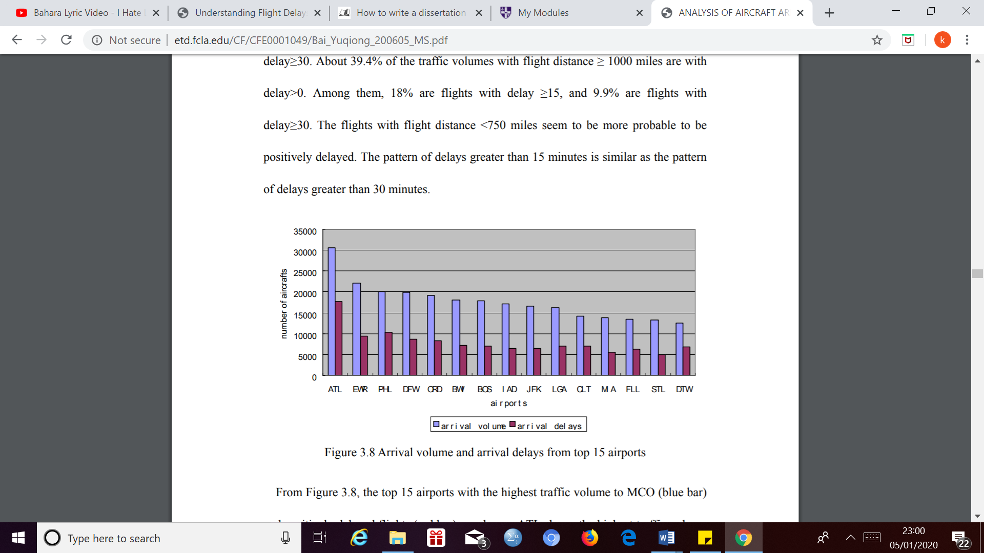

Figure 7 - the top 15 airports with the highest traffic volume to MCO and positively delayed flight (BAI, 2004).

Above is data from research carried out from MCO Airport in Orlando in the USA as 2002 and 2003. The data above proves that the increase of traffic volume would lead to there being a demand/ capacity imbalance especially figure 7 as the arrival delays are decreasing linearly with traffic volume with ATL sharing the highest traffic volume and 57.5% of arriving flights from ATL are delayed with this being the highest percentage of all 15 airports (BAI, 2004).

In figure 7 however if we observe closely during the morning, the percentage of delayed aircrafts is less compared to the percentage of traffic volume and this trend is reversed in the evening. The explanation to this could be that the traffic demand in the evening decreased along with the capacity or it could be due to the origin airport. Also, the small variation in departure from day to day is not sufficient enough to reach a capacity threshold which will increase the number of delayed aircrafts (BAI, 2004).

With a higher use of turboprops instead of regional jets delays can be mitigated as the turboprops require a smaller runway, climb more slowly and fly at lower altitudes compared to the jets. This means they can be naturally separated from the higher altitude jet traffic. Increased number of smaller jets, which operate in the same flight regime as the larger jet would mean more aircraft competing for the same airspace, this would lead to more congestion hence delays (R. Mueller* and B. Chatterji, 2002).

2.3 En-route delays

En – route delays are due to a lack of en-route airspace capacity. This may result due to an excessive peak of demand or even a lack of air traffic control staff due to sickness (ATEŞ, KAFALI and ÇELİKTAŞ, 2018).

Majority of the inefficiencies which occur within last 100NM of flight named terminal inefficiencies are mostly related to congestion leading to airborne holding patterns, metering and sequencing of arrivals. The inefficiency defined for the en-route part tends to avoid the air -port influence and terminal manoeuvring area’s (TMA) by considering a specific portion of the flight from gate to gate. This en-route efficiency is mainly driven by ATC routing, route utilization as well as en-route design. The en-route definition and ring reference near the airports is an arbitrary choice, as any other distance would be, as there is no harmonized for TMA horizontal limits. For this work, the en-route phase is defined as the segment of flight from the termination point of a departure procedure (the time the flight leaves the 40NM circle area around the departure airport) to the origination point of an arrival procedure (when entering the 100NM circle area around the arrival airport) (Sophie Piquet, 2017).

There are two key performance indicators used in today’s time for en-route flight efficiency. The first one developed measure’s the length of actual flight trajectories as additional distance with respect to an ideal flight, this is named achieved distance. The achieved distance is an apportion of the great circle distance between the two reference circles of 40NM at the departure area and 100NM at the arrival area. The GCD is the shortest distance between the two airports, flown in reference airspace. In an ideal situation (unrealistic and unachievable) situation where there is no congestion and each aircraft would be alone in the system, the horizontal flight efficiency indicators would be equal to zero. This situation only considers the horizontal component of a flight that is in general of a higher component and environmental importance. It excludes the vertical (altitude) component. The second key performance indicator used for en-route inefficiency developed by CANSO does not analyse the actual trajectory but compares the most recent filed flight plan and the bench mark achieved distance. The advantage of this KPI is that it measure’s the effect of wind, thunderstorms and other operational limitations, for example special use airspace which are contained in the flight plan. Air traffic control current studies on the indicators focus on taking the vertical navigation efficiency into account and better separate en route against terminal area performance (Sophie Piquet, 2017).

Figure 3 above shows that the average values of delays of each type in the summer period from 2008-2014. Generally, the data shows that the amount of delay during the earlier parts of summer the amount of delays were less compared to September. The proportion of delayed flights accounted for 50% during the summer months and only during September it dropped to 45%, This could be due to a higher engagement of the airspace leading to more delays due to the Domingo effect (R delays – reaction code) and Air traffic control delays (ATFMR) (Zámková, Prokop and Stolín, 2017). According to Euro control’s network the average en-route delays in 2018 were almost 3 times greater (1.73 minutes per flight) than the target delay per flight (0.5 minutes per flight). Around 28% of these were due to En-route air traffic control capacity constraints and 17% due to en-route ATC staff shortage, this only includes the major internal factors **(management, 2020****).** (Vaaben and Larsen, 2015) says that the second largest portion of primary delays were caused by factors related to Air traffic flow control management (ATCFM), this being 32.5% of the flights. This is when Eurocontrol takes care of the flow of the flights through various sectors in Europe. The largest subset of the ATFCM delays are en-route delays and correspond to 19.09% of all flight delays. En-route delays are the fastest growing source of delays with an increase of 17% from 2005 to 2010. The steep rise of en-route delays is due to the European Airspace being close to reaching its capacity limit, along with 19% of all flight delays in Europe in 2010. (Vaaben and Larsen, 2015).

During 2014 specifically there was 0.61 min average en-route AFTM delay per flight according to the network manager. This was for the total traffic of 9.6 million flights of which 3.2% were affected by ATFM. Aircraft operators experienced 0.4 minutes en-route ATFM delay per flight in 2014. (Ivanov et al., 2017)

According to NATS there were 2,635,849 movements in the UK during 2018.This being the busiest since 2007 when there were 2,627,565 movements with there being an 0.9% increase in 2018 relative to 2017. During 2018 delays attributable to NATS was 12.5 seconds on average per flight. If you exclude the delays generated by the implementation of EXCDS the underlying NATS en route delay was 7.7 seconds per flight. This is a massive change from 2007 where there were 26.8 second delays per flight (Rolfe, 2018).

Delays caused by operational control and crew duty norms (FOC) and delays caused by air traffic control (ATFMR) are more common across the larger aircrafts, this is as larger aircrafts need more time to check in at the airport hence it presents a challenge for the air traffic control (Zámková, Prokop and Stolín, 2017).

2.4 Weather related delays

According to studies adverse weather conditions account for up to 50% of air traffic delays within the US national airspace system. Also, after the analysis of the impact of different weather shocks on airline operations at the Atlanta Hartsfield International for one airline it is found that over 165,000 minutes of delays are due to adverse weather **(Borsky and Unterberger, 2019).** After studying several determining causes of flights delay at the Newark International airport, the main weather factors which have an impact on flight delays are low ceilings and low visibility conditions strongly influence flight delays, Weather contributed towards 69% of the delays according to **(Cheng et al., 2019).** Hsiao and Hansen’s analysis on daily average delay in the US domestic transportation system. (Borsky and Unterberger, 2019) found that delays on day with adverse weather are on average 14 minutes higher than on clear days. However according to **(Blackwood, 2020)** at Chicago O’Hare International Airport in 2010 only 6% of departure delays were caused by weather.

During the 1970’s rainfall substantially increased the number of flight delays by above 30 minutes at Chicago O Hare Airport (Borsky and Unterberger, 2019). After studying 2.14 million departure’s from 10 large U.S airport’s between January 2012 and September 2017, the following results were found. For sudden onset events, we find that flights which face a weather shock, are additionally delayed by up to 23 minute’s dependent on the type and intensity of the weather shock considered and for slow on set events it has been discovered, a significant impact of frost events on flight delays ranging between 2 and 3 min per flight events (Borsky and Unterberger, 2019). In terms of cold temperature as the temperature falls below 0 degrees Celsius the mean daily departure delays per flight increase if we control for airport and day fixed effects, the average daily increase in departure delays amount to 2 minutes per flight for temperature below -3 degrees Celsius, for rain intensities which exceed 0.1 inches per hour, the result suggested that rainfalls increase departure delays by 13 minutes, snowfall causes on average additional delay of around 11 minutes and lastly there is also an positive relationship between wind speed above 16mph and departure delay, on average between 2 to 3 minutes (Borsky and Unterberger, 2019). windspeed below 25mph does not cause any major disruption for smooth airport operations and the magnitude of delays are much smaller compared to rain and snow (Borsky and Unterberger, 2019). Runways are aligned along the main wind direction with air traffic control normally organizing traffic flows so that aircraft starts and lands into headwind, If the winds only have a ahead wind component, aircraft operations are possible up to windspeeds of 50mph (Borsky and Unterberger, 2019). The mean weather delay for each month in 2010 at Chicago O Hare Airport was no more than 6 minutes (Blackwood, 2020) and the range for mean weather and the range for mean and weather delays across months as 2 minutes to 5 minutes with the highest average weather delay in December of 5 minutes. During 2010 weather related departure delays were at a maximum amount on Fridays at an average of 5 minutes and minimum weather delays occurred on Wednesday (Blackwood, 2020).

Weather is the main source of flight delays associated with air traffic control causing more than 66% of departure’s and en-route delays in 1999 and 1998 (Board, 2020).

According to (Morrison and Winston, 2008) the weather which badly impairs visibility also causes around 70% of delays. If you may notice the percentage of delays caused due to weather is fairly similar across all three sources.

At many congested airports for example New York’s JFK and La Guardia, London’s Heathrow and Gatwick, Frankfurt and Hong Kong scheduled demand even in good weather is close to maximum capacity and during some hours will also exceed airport runway capacity. At many other airports, this tight relationship between capacity and demand prevails on days when weather conditions are less than optimal (Barnhart et al., 2012).

2.5. potential solutions and strategies

Airline delays can be solved internally by the airline for much more cheaply and efficiently. The majority of delay issues can be mitigated by real time management of their assets from a whole system perspective. An example of this can be if a flight lands 20 minutes late to San Francisco (SFO) because of congestion leading to a long approach path. If an airline manages to move the right two aircrafts forward a couple of minutes at the front end of a tightly packed arrival que of 30 aircrafts for instance it would save 2 minutes for every aircraft in the queue behind the first two flights as the entire queue moves forward, In the case above removing 60 minutes of the flight time and delay as the entire queue is pulled forward, reducing delays, flight times, fuel and carbon emissions hence reducing congestions As this is carried out the arrival to SFO would be 20 minutes late which would compound the problem.

As of normal schedule as the new crew arrives, does pre-flight checks and boards the aircraft would leave 25 minutes late and as each flight is planned independently, the flight from SFO to LAX is planned at normal speed. As there is pressure to reduce fuel costs, the crew slow down to save fuel hence landing 29 minutes late and as there is no one to park the aircraft or open the cabin door the arrival to LAX would be 32 minutes behind schedule **(Baiada, 2020).** On the other hand, according to (Vaaben and Larsen, 2015) congested airspace can be reduced by have flight plan arcs specifically to avoid congested airspace. This can be seen in figure 7 below where part A shows two flight plans. One flight plan traversing a congested volume of airspace, which will result in an estimated departure delay and another flight plan following and another flight plan following a sequence of waypoints taking the flight around the congested volume of airspace. Part B shows the corresponding arcs for flight f1. The leftmost solid arc represents the flight plan taking the flight around the congested airspace. The dashed arcs show that it may be relevant to speed up the flight for this trajectory due to the longer route. The left-hand side solid arc represents the flight plan taking the flight around the congested airspace. The dashed arcs show that it may be relevant to speed up the flight for this trajectory because of the longer route. The second solid arc for flight f1 is a representation for the direct flight plan, where the route traverses the congested airspace with a consequence of the flight departing with an estimated departure delay (CTOT).

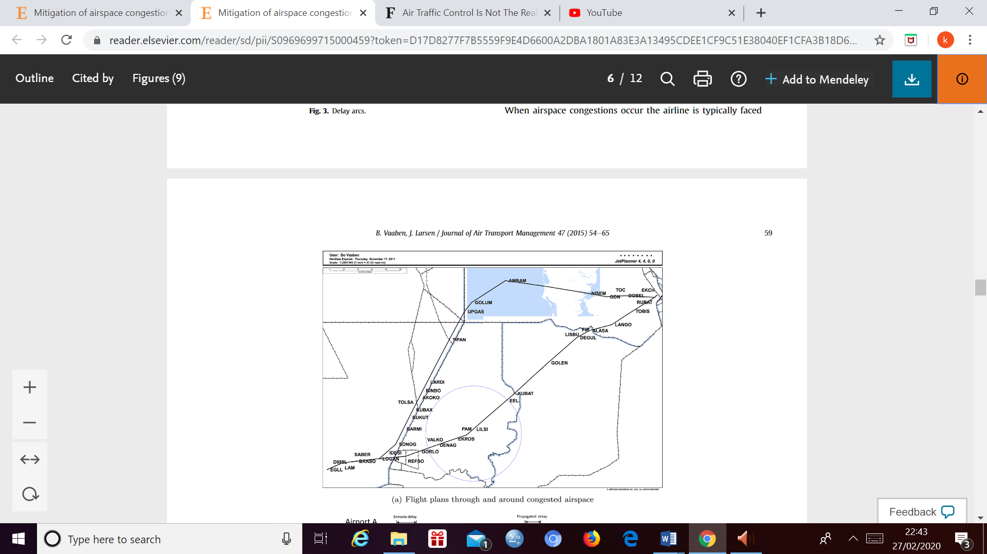

Figure 8A- flight plans through and around congested airspace (Vaaben and Larsen, 2015)

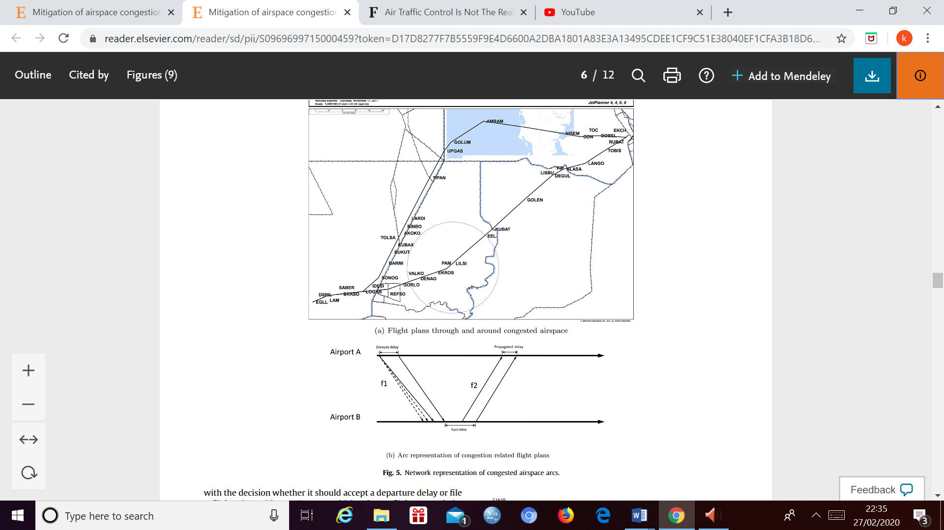

Figure 8B – network representation of congested airspace arcs (Vaaben and Larsen, 2015)

Satcom connectivity could transform the aircraft into a virtual crew room, eliminating the need for crew to visit a dedicated facility at the airport before a flight hence maximising on-time departure **(Aviation, 2020)**.

Airport’s which tend to have more gates tend to have less delays especially if the gates are unscheduled so they can promptly handle early or late arriving aircrafts (Morrison and Winston, 2008). Lastly **(Baiada, 2020**). says that there is a proven process called operational excellence which keeps the crew and aircraft together, a fast turn is carried out and departs only 15 minutes late. Next, the flight plan gives pilots extra fuel to let them fly low and quick and according to the situation mentioned above it would mean that they would arrive into LAX only 10 minutes late as ramp personnel are linked in real-time to a fluid, dynamic production process, they are ready to guide the aircraft to the gate and move the jetway to open the aircraft door, allowing a fast turn. With this process rather than two legs being late and getting even later, after two legs the flight will be back to schedule.

2.6 Evaluation and research gap

Overall from the information above we learn about the various internal and external factors which cause delays and potential solutions to mitigate them with specific examples. Internal factors consisting of demand-capacity imbalance, technical issue’s and operational errors. External factors consisting of weather-related issues.

Some of the internal factors which impact the amount of delays are inter-related as (BAI, 2004) discovers that the airports with the highest traffic volume to MCO had the greatest amount of positively delayed flights. According to (Zámková, Prokop and Stolín, 2017) the greatest amount of delays was during the early/middle parts of summer (June/July) compared to the later parts of the summer (September) as the amount of delayed decreased from 50% to 45% and the explanation for this was due to there being a more congested airspace during the earlier parts of summer hence there being more delays due to the Domingo effect and air traffic control delays whereas (Lambelho et al., 2020) relates the growth of air traffic to the demand/capacity imbalance at the airport. Apart from this (Zámková, Prokop and Stolín, 2017) also explains that there are more delays during the summer period due to technical deficiencies as there is a heavier usage at that period of time.

Apart from this the other link we can make is that the amount of delays will vary depending upon timing of the flight as well as the certain stages of the flight as discovered by (R. Mueller* and B. Chatterji, 2002 and (Zámková, Prokop and Stolín, 2017) as during the night the repair and maintenance work tends to be carried out during the night and 84% of all delays tend to be carried out on the ground. This would help us come up with specific solutions for mitigating delays as we understand when they occur.

In terms of external factors which have an impact on aviation delays it mainly consists of poor weather conditions. According to (Borsky and Unterberger, 2019) there is a positive correlation between certain adverse weather conditions and delays such as when the temperature falls below -3 degrees the average daily increase in departure daily is 2 minutes per flight, for rain intensities which exceed 0.1 inches per hour, it is calculated that there is an increase of 13 minute increase of departure delay and with stronger intensities of rainfall the departure delay increasing up to 23 minute’s etc.

According to (Cheng et al., 2019), (Board, 2020) and (Morrison and Winston, 2008) weather contribute’ s around the same amount to delays of in between 65-70%.

We can link the principle cause of delays which states that delays occur due to a capacity- demand imbalance to weather conditions as (Barnhart et al., 2012) states that there is already a tight relationship in major airports in terms of a capacity and demand imbalance when there is good weather but at other airports when the weather conditions are less than optimal the demand exceeds the capacity.

There has been a lot of research carried out regarding factors influencing delays at major airports and airline’s which are relatively large in scale however there has not been enough research carried out for smaller regional airline’s and airports hence I am studying factors influencing delays at a regional airport.

Methodology

3.1. Research Aim and objectives

Aim: To investigate the causes of aviation delays and possible mitigation methods.

1) To identify factors which are affecting aviation delays

2) To examine factors affecting delays at regional airports with the use of data from Aurigny Airlines.

3) To provide solutions to policy makers and practitioners for mitigating air traffic delays

3.2. Research Design

|  |  |  |  |
| --- | --- | --- | --- |
| Objective Number | Objective | Methods | Chapter |
| 1 | To identify factors which are affecting aviation delays | Literature review | 2 |
| 2 | To examine factors affecting delays at regional airports with the use of data from Aurigny Airlines | Data analysis of delay data from Aurigny Airlines | 4 |
| 3 | To provide solutions to policy makers and for practitioners mitigating air traffic delays | Literature review and discussion | 2 &4 |

Table 2- research objectives and their method of completing them

This table shows how the research objectives were met with there being a mixture of going over various journals and delay data there have been provided from Aurigny Airlines for 2016.

3.3 Research context

The research is regarding Aurigny Airlines which is based in Guernsey. The owner of Aurigny Airline’s is Sir Derrick Bailey. Guernsey is a channel island just off the coast of Normandy (France). Aurigny Airline’s was first founded on the 1st March of 1968 and is a scheduled airline, In the first year of operation 45,000 passengers were carried out by the airlines (Aurigny, 2020). This is very impressive especially if you compare it to Ryanair which carried 82,000 passengers in its first year (Boon, 2020). Aurigny Airline's is a regional carrier. Although there is no definition at EU level for a regional airport but according to ACI Europe an airport should be considered regional if it primarily serves short and medium range routes and primarily serves point to point destinations (Jankovic, 2017). Aurigny airlines is known to be one of the smaller regional airlines in Europe. Aurigny airline’s is one of the rare regional airlines which offers a frequent flyer programme. A return flight from Guernsey to Alderney earns you 300 points and if you obtain 2400 points you get a return flight free from Guernsey to Alderney (Aurigny, 2020).

Aurigny Airlines major hubs are at Guernsey airport and Alderney Airport. The routes from Guernsey Airport are to Alderney, Birmingham, Bournemouth, Bristol, Cornwall, Dusseldorf, East Midlands, Edinburgh, Exeter, Glasgow, Grenoble, Jersey, Leeds Bradford, London (Gatwick and Stanstead), Manchester, Norwich and Southampton. Aurigny Airline’s flies to 11 of these destinations. This being Grenoble (seasonal), Alderney, Exeter, Southampton, Bristol, Birmingham, Manchester, Leeds Bradford (seasonal), East Midlands, Norwich (Seasonal), London (Stansted and Gatwick) (aurigny, 2020).

London is a major route for Aurigny airlines. They serve the London market up to 7 times daily with 6 flight rotations to Gatwick and 1 to Stansted. The route between Alderney and Guernsey is also fairly significant where they fly 4 times daily and we ensure we have the capacity to put on additional services at peak times and they provide ‘Medevac’ flights on behalf of the hospital in Alderney when it is important to transfer residents to Guernsey for medical treatment and during 2018 there were 50 of these flights which were provided to Guernsey’s HSC at marginal cost. They also connect Alderney with Southampton 3 times daily (haining, Darby and Simpson, 2018).

Aurigny Airline’s has a fleet of 9 different aircrafts serving the network, The Embraer 195 is the flagship carrier and serves the Guernsey – Gatwick Route. The twinjet aircraft is the largest aircraft in the fleet with a capacity of 122 passengers which first started in July 2014, this has a range of 2500KM. They also have 4 ATR’s which help serve our UK and European destinations with the newest addition being a fully re-furbished ATR 72-500 which is delivered towards the end of 2016 and fitted with 72 new all forward-facing seats that give additional legroom and has a range of 1023 miles. The delivery of our second new generation Dornier 228 in 2017 was to serve the Alderney routes (aurigny, 2020).

In many regions of Europe there are few efficient alternative’s to air travel due to a combination of factors such as distance, low population density, geographic and climatic constraints. Guernsey Airport can be an example of this due to its geographic location being in a channel island hence travel to other destinations would be inconvenient by other modes of transport. Aviation in these regions would be very important to provide access to essential services such as Healthcare as Aurigny Airline have done regarding the route in between Alderney and Guernsey. The European airport network offers unrivalled connectivity and mobility, in fact around 90% of this network is made up of regional airports. As of 2017 there were 2019 air carriers, 14,600 routes and a total of 724 destinations. The increasing level of congestions at more larger airports and the emergence of new (low cost and point to point) airline models lead to regional airports having a significant growth over the previous 25 years. In between 1993 and 2015 traffic at regional airports in Europe increased by 173% and in today’s time within Europe regional airports handle an excess of 800 million passengers each year (Jankovec, 2017). Aurigny Air carried 544,033 passengers in 2017 and a smaller amount of 531,354 in 2018(haining, Darby and Simpson, 2018).

3.4.1.data description

I am using secondary data provided by Aurigny Air for the year 2016 to analyse which factors mainly affect delays for Aurigny Air based in Guernsey. The dataset provided by Aurigny Airlines consists of flights from the 2nd January 2016 to 31st January 2016. There are 6091 flight observation altogether in my dataset. The data set contains the flight number, the aircraft type, the aircraft registration, the standard time of departure, the airport the aircraft is meant to depart from and arrive from and the actual airport it departs from and arrives to. The dataset also consists of the standard time of arrival and actual time of departure with the actual time of arrival. It also has the delay codes with the amount of delay corresponding to the delay code with their being up to two delay codes on each flight. Lastly the dataset consists of the difference in between the actual time of departure and standard time of departure. I have modified some of my variables to help me analyse the relationship between flight delays and the variables.

Apart from this I have found data regarding the daily weather conditions at Guernsey Airport (GCI) for 2016. I found this information from the Guernsey Met office annual report for the year 2016. I included the average daily temperature (degrees Celsius), daily amount of rainfall (mm) and average daily windspeed at Guernsey (knots) variable’s to help me analyse the relationship between the weather conditions and the delay’s in minute’s for flight’s departing and arriving from Guernsey Airport. The possible limitation with this data is that the hourly data for the windspeed, rainfall and temperature were not present for us to compare the delay’s with the weather conditions with each particular flight at Guernsey Airport (GCI) (Archard, 2017).

|  |  |  |  |  |
| --- | --- | --- | --- | --- |
| **Variable name** | **Types of variables** | **Variable characteristics** | **Value’s** | **Variable source** |
| Delays in minutes | Dependent | Scale | -110 – 577  (Minutes) | Aurigny dataset |
| Seasons: winter, Summer, spring and (autumn) | Independent | Nominal | (1,0) | Modified from Aurigny dataset |
| Time of day: morning, afternoon and (evening) | Independent | Nominal | (1,0) | Modified from Aurigny dataset |
| Range | Independent | scale | 0-1280  (minutes) | Modified from aurigny dataset |
| Cause of delay: airline delay, airport delay, weather delay and (en-route delay) | Independent | Nominal | (1,0) | Modified from Aurigny dataset |
| Arrived from London | Independent | nominal | (1,0) | Modified from Aurigny dataset |
| Departed from London | Independent | nominal | (1,0) | Modified from Aurigny dataset |
| Average daily temperature at Guernsey airport for 2016 | Independent | Scale | 2.7- 26.5  (Degrees Celsius) | Guernsey Met Office annual report for 2016 |
| Daily amount of rainfall at Guernsey Airport for 2016 | Independent | Scale | 0-33.3  (mm) | Guernsey Met Office annual report for 2016 |
| Average daily windspeed at Guernsey Airport for 2016 | Independent | Scale | 1.2-31  (knots) | Guernsey Met Office annual report for 2016 |

Table 3-information to show the variable’s used in the project

3.4.2. Data processing

Firstly, I have separated all my flight date’s into their corresponding seasons. The winter time period from my dataset is from the 2nd of January 2016 up to 29th of February 2016 and 1st of December up to 31st December 2016. The spring time period is from the 1st of March 2016 up to 31st of May 2016. The summer time period is from the 1st of June 2016 up to 31st August 2016. Lastly the autumn term lasts from the 1st of September 2016 up to the 30th November 2016. I created a dummy variable for each season. Apart from this I also separated each flight into their corresponding time of the day (morning, afternoon and evening). The flight is considered to be in the morning if it is from 6am till 12pm. The flight is considered to be in the afternoon if it is from 1pm till 5pm and lastly the flight is considered to be in the evening if it is from 6pm till 12am. I made sure the flight was at its nearest hour to make sure there are no complications in determining what period of day the flight is in and created a dummy variable for each period of the day. Apart from this I managed to work out the range (KM) of each route Aurigny Air travels to as this was not part of the original dataset. I also separated the flights which departed from London and arrived at London to flights departing and arriving from other airports to see the delays vary with routes to and from London to all other routes, I created a dummy variable for these specific routes also. I also managed to create a variable to identify the delay time in minutes for each individual flight in 2016. Lastly in terms of modifications of my variables I identified what each delay code related to in terms of the actual reason for the delay. Next, I categorised the causes of delays into four separate categories: Airline delay dummy variable, Airport delay dummy variable, weather delay dummy and air traffic delay dummy. I decided which categories the delays go on based upon my previous literature research. Dependent variable is a variable which we are trying to measure and can be affected by external factors and an independent variable is something which does not depend on other variables and is something which we change in a study. In our study the dependent variables are the delay time in minutes and the independent variables are the seasons: winter, spring, autumn and summer, the time period of the day: morning, afternoon and evening, the range of the flight, the flight arriving and departing from London and the categories of the various causes of the flight: airport delay dummy, airline delay dummy, weather delay dummy and air traffic delay dummy. All of my independent variables are nominal apart from the range which is a scale measurement and my dependent variable the delay time in minutes is a scale variable.

To identify the relationship in between the weather conditions at Guernsey Airport with its corresponding weather conditions I filtered out flight’s departing from and arriving to Guernsey Airport along with its corresponding date’s and delays (minute’s) in each particular flight.

Data analysis 3.4.3

I analysed my data using a mixture of SPSS software which is used for statistical analysis specifically and mainly for linear regression models. With the use of excel I carried out descriptive statistics. I used a book by (Francis and Field, 2011) called discovering statistics using SPSS to help me understand the SPSS software and it’s functions more deeply.

Firstly, with the use of SPSS I created a histogram of delays in minutes along with its frequency. In terms of my linear regression models I first created a model between the delays in minutes along with the seasons, I kept the Autumn season as a reference to compare to as the other seasons had a lower amount of delay relative to Autumn in terms of the B value. I created my linear regression models by simply putting the relative data in to the correct sections. For instance, in this case I added the delays in minutes in the dependent section and the relevant seasons in this case Summer, Spring and Winter into the independent section. After doing this I got the information of the B value and level of significance etc.

The next linear regression model I created was in between the flights arriving and departing from London and the amount of delays (mins). The independent variable’s being the flights arriving and departing from London.

After this I created a linear regression model between the cause of delay and the delays in minutes. The causes of delays included: Airline delays, weather delays, airport delays and air traffic delays. Once again, the dependent variable being the delays in minutes. My reference cause was air traffic delays as I expected it have the lowest amount of delays.

The next linear regression model was between delays in minutes and the range of the flight (the distance of each flight). Lastly followed by the times of the day and the delays in minutes. The reference time of day being in the evening as other times of the day had a higher amount of delays in terms of the B value. I used the SPSS software to complete a scatter plot between the amount of delays and the range of flights to illustrate the relationship between the two variables.

I used the Excel software to complete descriptive statistics as I mentioned earlier. I mainly focused on the amount of delays and I managed to calculate the mean (average amount of delays), median amount of delays (central value when in order), standard deviation of the amount of delays (spread from the mean), the mode (most common amount of delays), the lower and upper quartiles of the amount of delays and finally the outliers. I calculated most of the descriptive statistics by simply highlighting the amount of delays column and using the statistical function before selecting the required statistical function e.g. average and standard deviation. To work out the outliers I worked out the upper and lower limits with the formula $Q1-(1.5×IQR)$ for the lower limits and the upper limit with the formula $Q3+(1.5×IQR)$. The IQR value is the interquartile range calculated by the upper quartile (Q3) – the lower quartile (Q1). The outliers were any value below the lower limit or above the upper limit. I also calculated the average delay per each cause (airline, airport, weather and air traffic) by filtering out each delay and using the statistical function to calculate the average across the total number of delays. I also worked out the percentage of flight’s which were delayed above 15 minutes and 104 minutes for each particular cause by working the amount of flight’s which were delayed for longer than 15 minutes and 104 minutes’ firstly then filtering out particular cause and dividing it by the total number of flight’s delayed above the particular amount shown above.

Lastly, I used the data related to the weather conditions at Guernsey airport from the Met Office annual report for 2016 by identifying the correlation coefficient value between the delays in minute’s with the daily amount of rainfall, average daily temperature and the average daily windspeed(Archard, 2017). I identified the correlation co-efficient value with the use of Excel Software once again. I separated the flight’s departing from Guernsey Airport and Arriving to Guernsey Airport and how the weather condition’s mentioned above impacted the delay’s at Guernsey Airport.

4.0. results

4.1. Descriptive Statistics

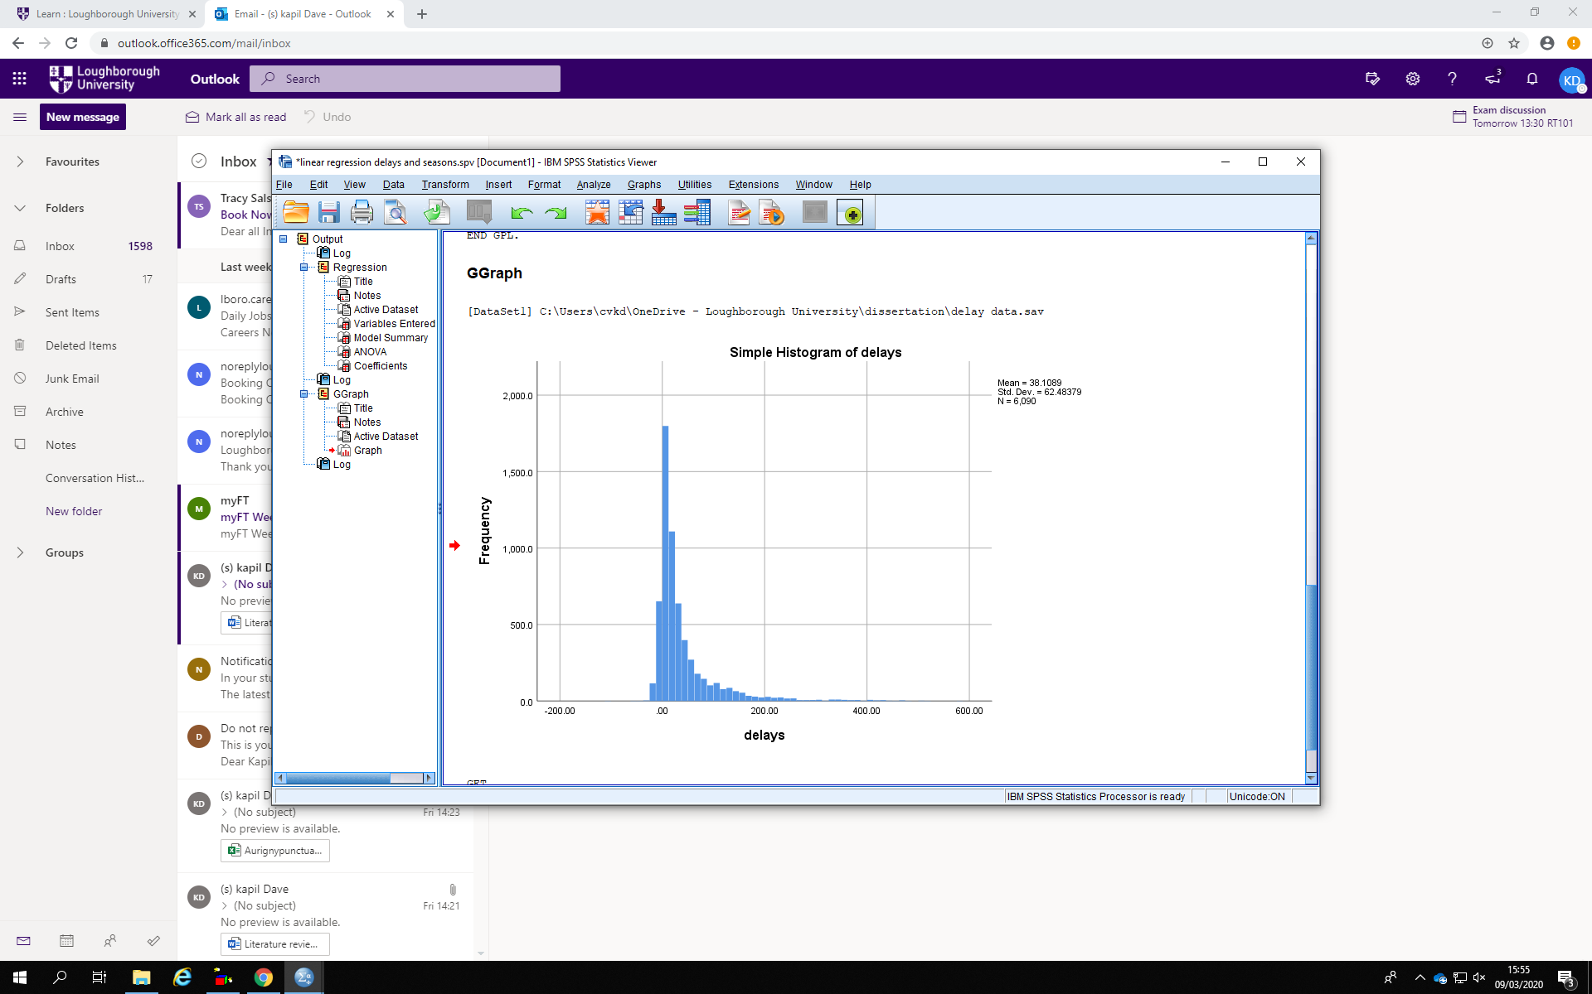

Figure 9 – histogram to illustrate Aurigny Airline’s amount of delays in minute’s and how frequently they occur.

The histogram above has a similar shape of a normal distribution curve if we draw a normal distribution curve on the histogram. The mean amount of delay’s for Aurigny Airline’s in 2016 was 37.1 minutes and the median amount of delays being 15 minutes’. The mean in this case represents the average amount of delays across each individual flight across 2016 and the median represents the central value for amount of delays throughout 2016. The mode which is the most commonly occurring amount of delay was 9 minutes. The histogram above is positively skewed. We can tell this by the mode being lower than the median and the median being lower than the mean (Glen, 2020).

.

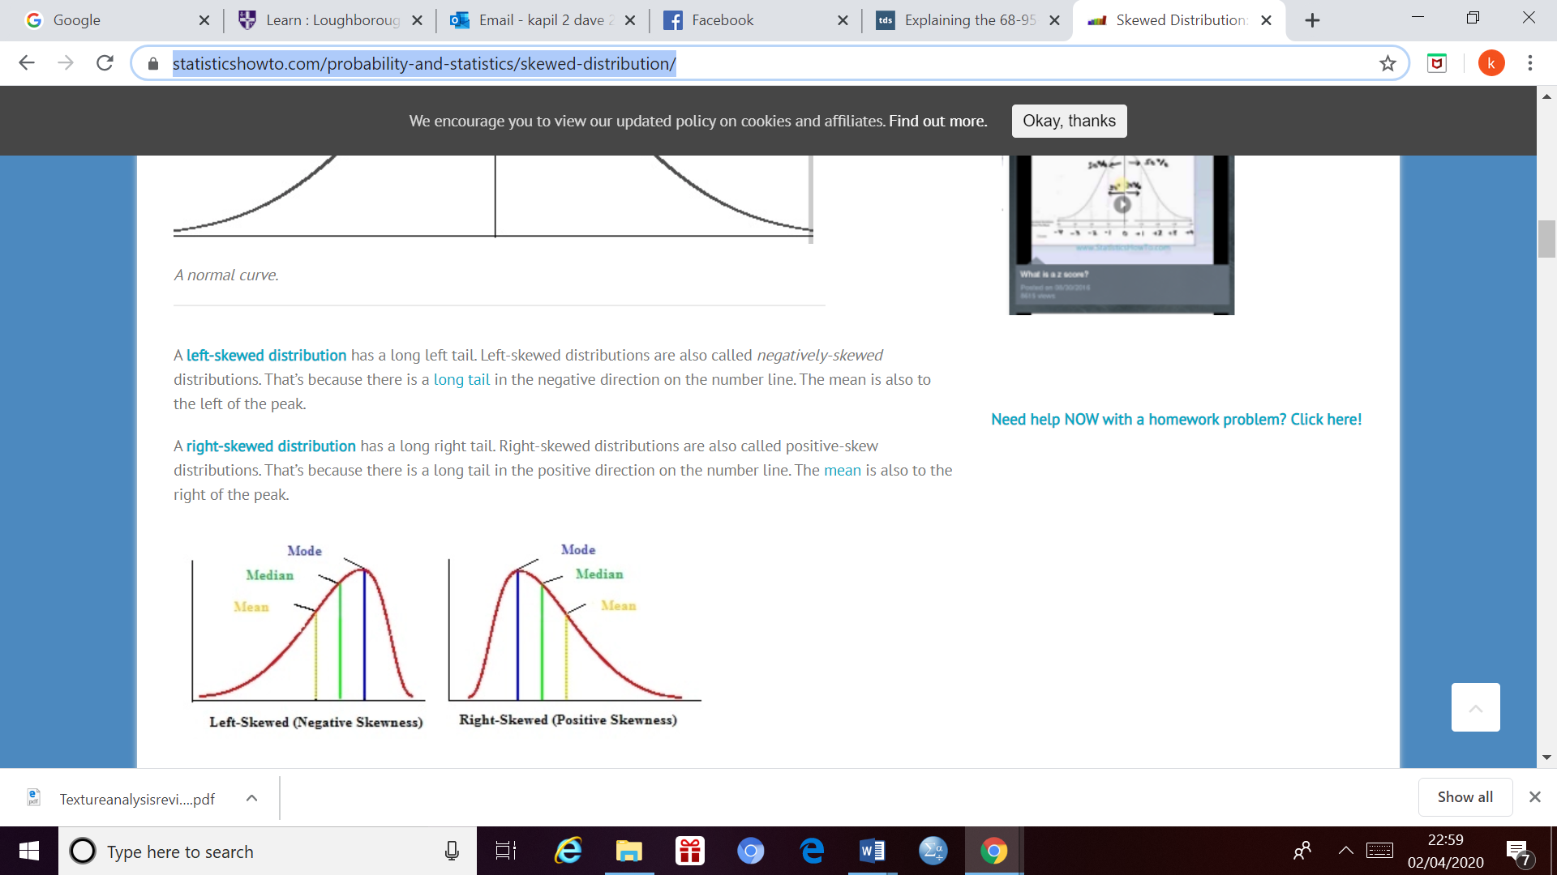

Figure 10- illustration of a positively skewed normal distribution curve (Glen, 2020)

The standard deviation measure’s the spread of dataset from its mean, in this case how spread the delays were from its mean which was 37.1 minutes. The standard value which I got was 61.5. Figure 2 below shows that 68.3% of the data lies between 1 standard deviation of the mean, 95.5% of the data lies between 2 standard deviations of the mean and 99.7% of the mean lies between 3 standard deviations from the mean (Galarnyk, 2018). If you look at the histogram above, we can see that it is around the same case as the normal distribution curve shown on figure 2. As if we add 3 standard deviations from the mean the value is 221.6 minutes and the frequency of delays after this value is really low hence, we can assume that almost 100% of the delays are covered within 3 standard deviations especially after knowing that all of the delays are covered within one standard deviation if we take it away from the mean.

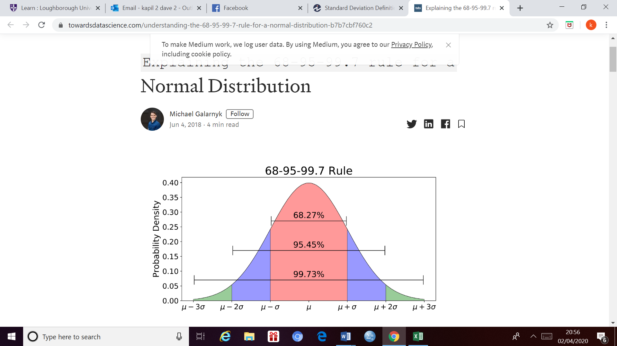

Figure 11- normal distribution curve with the probability density function (Galarnyk, 2018)

The lower quartile I calculated was 4 hence 75% of the data (delays in minutes) is above this value and 25% of the data is below this value. The upper quartile of the data is 44 minutes with 75% of the delays being below this value and 25% of the data above this value. There were a quite a few outliers above the upper range limit which was 104 minutes relative to the lower range limit of -56 minutes. 10% of the flights were delayed/arrived above 104 minutes’ compared to the actual time of departure. None of the flights were less than 56 minutes early hence below the lower range limit. A delay is defined as flights departing or arriving 15 minutes above the scheduled time (Lambelho et al., 2020). In 2016 55.8% of Aurigny Airline’s flights departed/ arrived 15 minutes or greater than the scheduled time hence we can assume that just above half of Aurigny Airline’s flights were delayed.

From the histogram above along with the descriptive statistics we understand that majority of the delays tend to be fairly short especially with the knowledge that a delay is defined if flights arrive or depart at least 15 minutes after the scheduled time (Lambelho et al., 2020). Around 40% of the delays (above 15 minute’s) tend to be between 15 to 30 minutes and only 10% of the flights are considered to be an outlier in terms of them arriving/ departing above the upper range limit. There are no flight’s which depart before the scheduled time.

In total there were 3397 flight’s which were delayed by greater than 15 minutes’. The interesting fact is that only 1150 (34.7%) of the flight’s above 15 minutes’ came under of the four categories of delays (weather, airline, airport and en-route). The rest of the delays were reactionary delays or other types of delays categorised as others by IATA in their delay code’s. Airline related delays contributed towards 21.1% of all flight delays greater than 15 minutes, airport related delays contributed towards 4.2% of all flight’s greater than 15 minute’s, weather related delay’s contributed towards 7.7% of all delays greater than 15 minutes and finally air traffic control related delays contributed toward 0.9% of all delays greater than 15 minutes.

Out of those delays which above the upper range limit (104 minutes) and considered an outlier the major causes were the weather (15.4%) and Airline related factors (13.2%). Airport related factors only contributed towards 1.4% along with air traffic control reasons only contributing 0.3% towards the delays greater than 104 minutes.

Table 4 – average delays in minutes per each cause of delay

|  |  |
| --- | --- |
| Cause of delay | Average delay per cause (minutes) |
| Airline related delays | 24.6 |
| Airport related delays | 14.6 |
| Weather related delays | 91.1 |
| Air traffic control related delays | 18.4 |

4.2. correlation coefficient values

In terms of identifying the impact certain weather conditions at Guernsey Airport had on the delays in flight’s, I worked out the Pearson Correlation Coefficient value’s as mentioned earlier. They are summarised on the table below.

|  |  |
| --- | --- |
| Correlation Coefficient value for delays in minutes and weather condition for flights: | |
| Weather condition | Departing from Guernsey | Arriving to Guernsey |
| Daily Rainfall (mm) | 0.009 | -0.092 |
| Average daily temperature (degrees Celsius) | 0.036 | -0.195 |
| Average daily windspeed (knots) | 0.007 | -0.165 |

Table 5 – summary of correlation coefficient value identified between various weather conditions at Guernsey Airport and their corresponding delays

The Pearson’s Correlation coefficient value’s measures the strength of the linear relationship and the symbol for when it is measured in a sample is r. Pearson’s r value can range from -1 to 1. An r value of 1 would indicate a perfect positive relationship, an r value of 0 would indicate no linear relationship between the variable’s and an r value of -1 would indicate a perfect negative relationship between the variables (M. Lane, 2020). These are illustrated in the diagrams below.

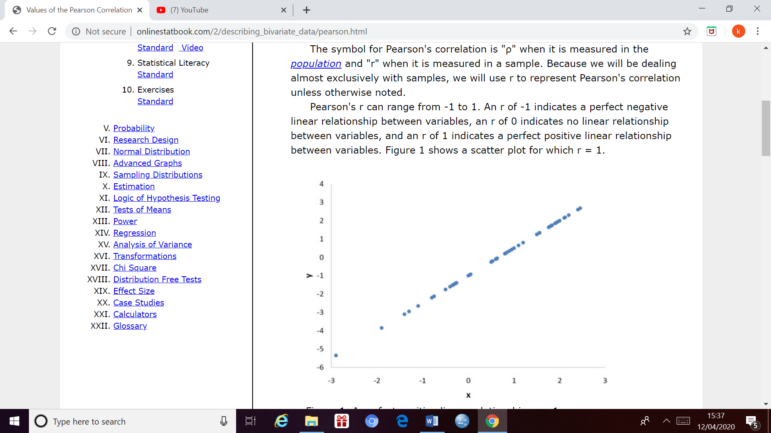

Figure 11- the scatter plot shown on figure 11 illustrates a perfect positive linear relationship where the r value is 1 (M.Lane, 2020)

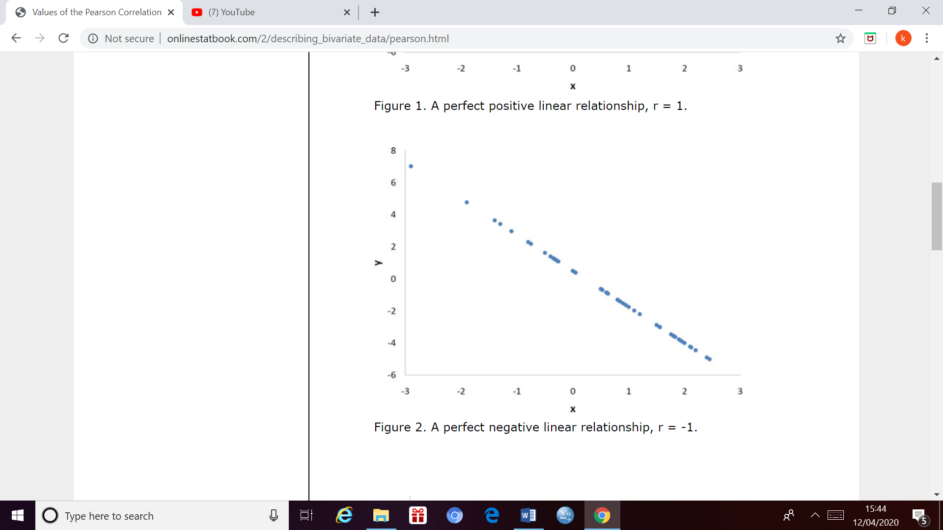

Figure 12- the scatter plot shown on figure 12 illustrates a perfect negative relationship with the r value of -1 (M. Lane, 2020)

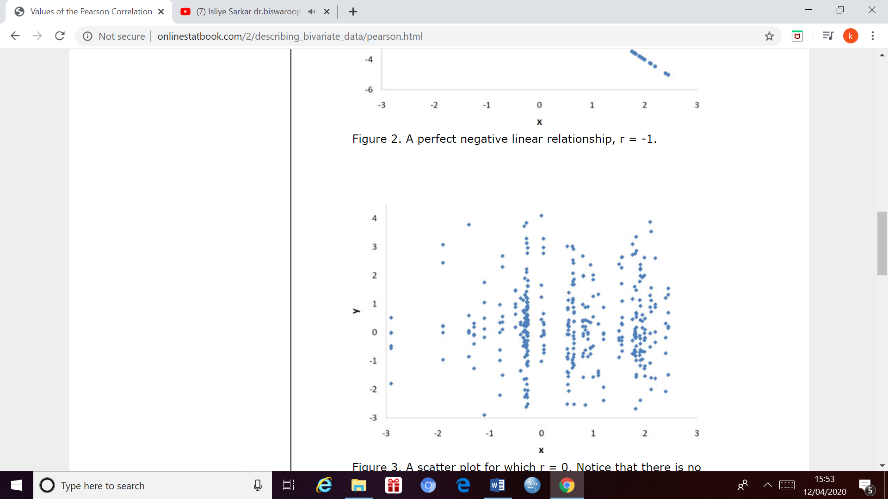

Figure 13 – the scatter plot shown on figure 13 indicates no linear relationship with the r value of 0 (M. Lane, 2020)

With this knowledge we can interpret that the relationship in between delays of flight’s which are departing from guernsey and the daily rainfall and average daily windspeed being negligible as the r value is very small. The r value for the relationship in between the average daily temperature and the delays of flight’s departing from Guernsey is slightly larger indicating a slightly larger linear positive relationship but the value is too small hence there is a very weak linear positive relationship.

The major difference between the relationship of delays when flights are departing from Guernsey and delays when flights are arriving to Guernsey are that each of the r values are negative when flights are arriving to Guernsey. This indicate’ s that there is a negative relationship in between the delays of flight’s arriving to Guernsey and the various weather conditions. This r value’s for each type of weather condition is fairly similar. There is more of a correlation for flight’s arriving to Guernsey Airport and the weather conditions relative to flight’s departing from Guernsey Airport but overall there is a weak negative relationship as each of the r values are below -0.20. This means that as the delays of flight’s arriving to Guernsey airport decrease’s the daily rainfall, average daily temperature and Average daily windspeed increases.

4.3. Linear Regression Models

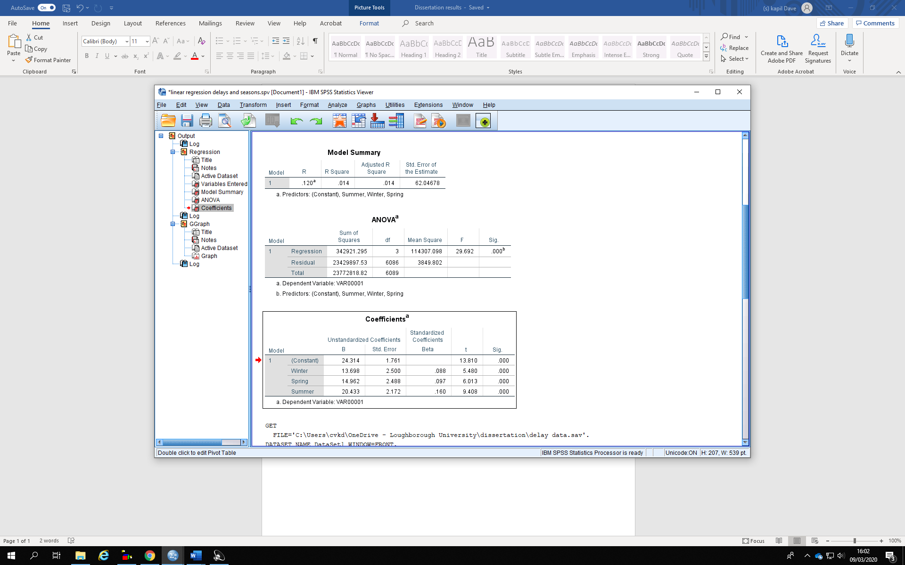

Figure 14- linear regression model between the seasons and the delays in minute’s

Figure 14 above show’s how delay’s varied in each season for Aurigny Airline’s in 2016 with the Autumn term being as a reference. All of the variable’s above are significant, as the p value is less than 0.10. The B value above shows that each delay is 13.7 minute’s more in winter compared to Autumn, 15.0 minute more in winter relative to Autumn and 20.4 more minute’s more in summer compared to Autumn. Overall Summer has the greatest amount of delays followed by Spring with Autumn having the least amount of delays.

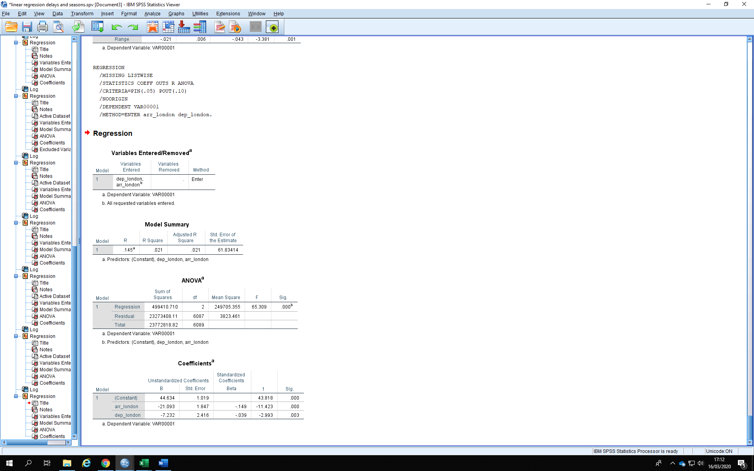

Figure 15- linear regression model between the flight’s arriving and departing from London and delays in minutes

Figure 15 shows the relationship between Aurigny Airline flight’s arriving to London or departing from London and the delays in minutes of each of these particular flights. Both the independent variable’s (flight’s arriving to London and departing from London) are significant as the p value is less than 0.10. According to the b value’s above each flight arriving to London arrives 21.1 minute’s early compared to other flight’s and flight’s departing from London arrive 7.2 minutes early compared to other flights.

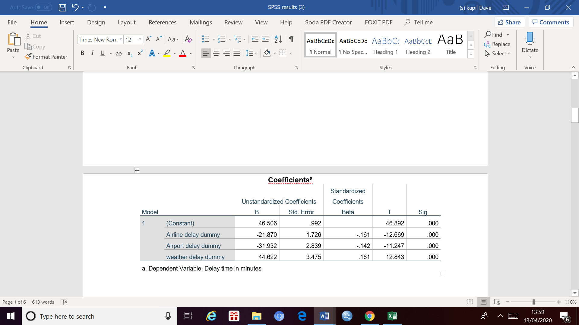

Figure 16- linear regression model between causes of delay and delay’s in minute’s

Figure 16 above shows the relationship in between the causes of delays and the delay’s in minute’s with air traffic delays being the reference cause. All of the variable’s in the model are significant once again as the p value is lower than 0.10. Airline related delays are 21.9 minutes less per delay relative to Air traffic related delays. Airport related delays are 31.9 minutes’ less per delay relative to air traffic delays. Weather related delays however are a significant 44.6 more minutes per delay relative to air traffic delays.

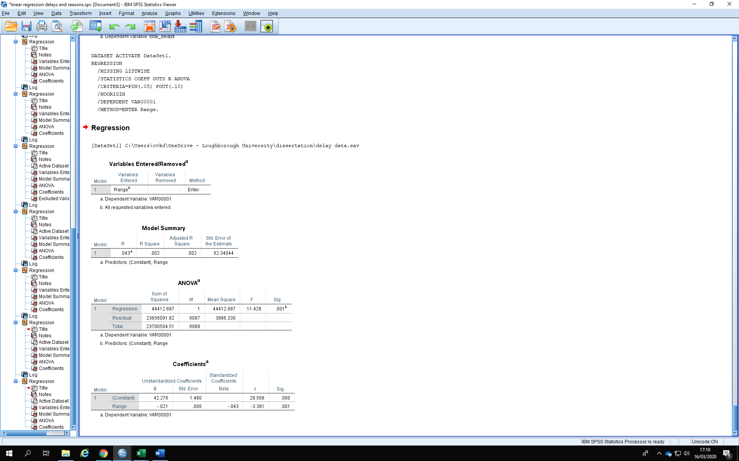

Figure 17- linear regression model in between the range of each flight and the delays in minute’s

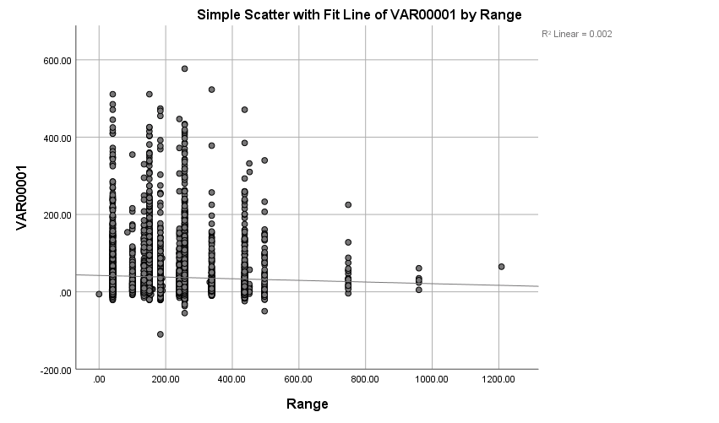

Figure 18 – simple scatter plot of delays in minute’s with the range of each flight

In figure 18 above you can see that the range variable is significant as the p value is below 0.10. According to the b value in figure 7 as the range of the flight increase’s by 1km the delays in minute’s decrease’s by 0.021 minute’s. This is illustrated by figure 8 where you can see the line of best fit is sloping slightly downwards.

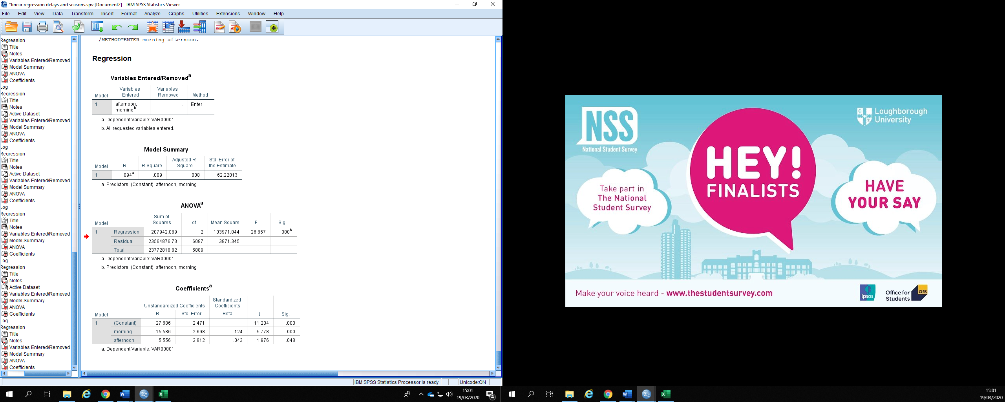

Figure 19 – linear regression model between the time of the day and the delay in minute’s

Figure 19 above shows the relationship between the time of the day and the delay in minute’s with using the evening as a reference. Both variable’s in the model are significant as the p values are below 0.10. In the morning the delays are 15.6 minute’s more per each delay relative to the evening and in the afternoon the delays are 5.6 minute’s more per each delay relative to the evening.

4.4. multi-nomial linear regression model

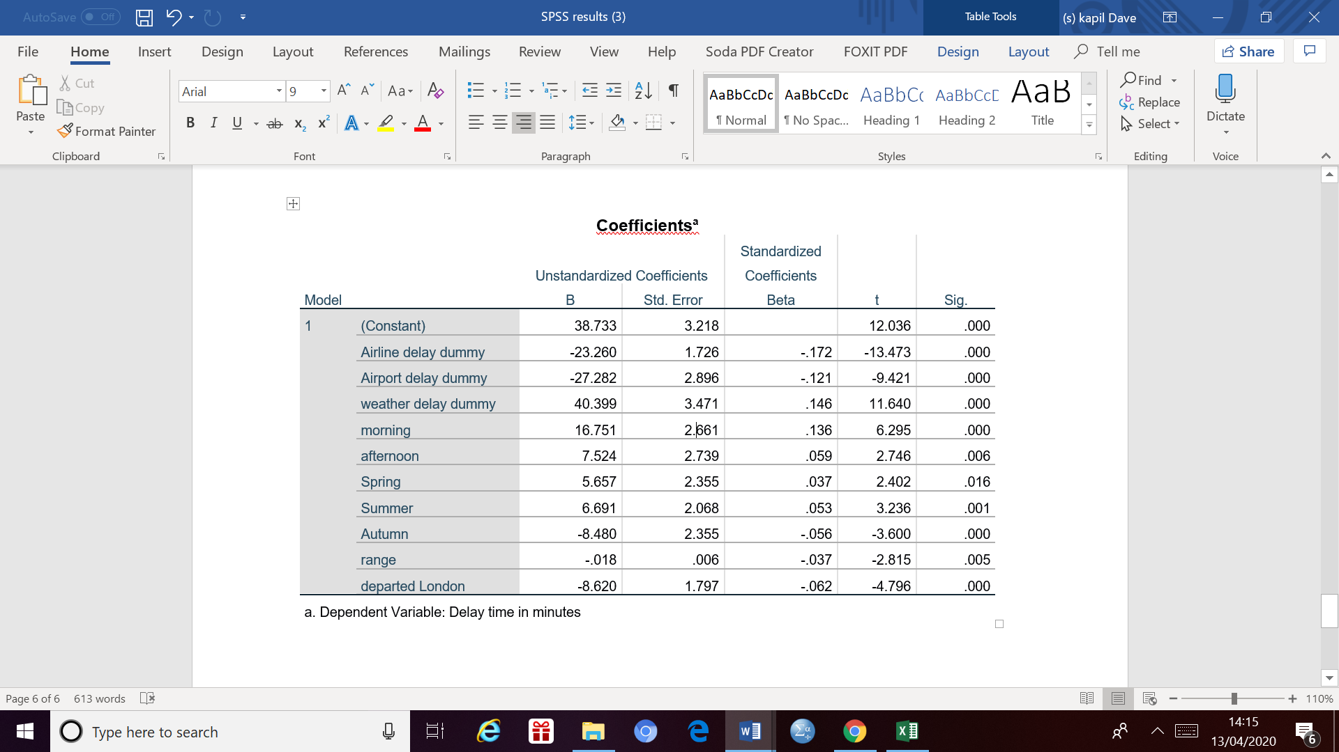

Figure 20 –linear regression model between majority of independent variables and the delay in minute’s

From the linear regression model shown above in figure 20 we can identify which variables are significant and which variables are not. According to the model above all of the variables are significant as the p value is smaller than 0.10 hence has reliability of greater than 90%.

Overall the major conclusions we can make from the linear regression models are that weather-related delays tend to have the greatest impact on delays in minute’s. Flight’s departing from or arriving to London don’t have a major impact on delays. There is not a major difference between the seasons in terms of the impact they have on the delays in minute’s with the summer having slightly more delays in minute’s compare to the other seasons with the Autumn season having the least impact on delays. The highest amount of delay’s tends to be in the morning with the evening having the least amount of delays. The range of the flight has a very small impact on delays in minute’s with the delay’s decreasing very slightly as the distance of the flight increases.

5.0. Discussion

In this chapter I will discuss the results I obtained in my previous chapter by comparing my findings in chapter four to previously carried out research and journal paper’s I found in chapter two. I will provide explanations to any differences I have found from previous literature to my own findings.

The structure of this chapter will be similar to chapter 2. In the first section in this chapter I will discuss airline related delays (Aurigny Air in our case), in the second section I will discuss airport related delays, In the third section I will discuss delays due to air traffic control, In the fourth section I will discuss delays due to the weather.

I will incorporate the various factors apart from the causes itself such as the range of the flight, seasons and the time of the day within the chapter in various sections to see how they also play a role in affecting the delays of each flight along with the causes. I will mainly focus on delays which are greater than 15 minutes from my dataset. This is because delays are defined as the flight arriving or departing at least 15 minutes’ after the scheduled time (Lambelho et al., 2020) hence it would make a fair comparison between other airline’s and flight’s across other part’s of the world more generally.

5.1. Airline related delays

In chapter two I discussed that airline related delays included delays due to baggage and luggage, aircraft damage and operations computer failure and lastly flight operations (ATEŞ, KAFALI and ÇELİKTAŞ, 2018). I categorised airline related delays with similar factors within my dataset (passenger and baggage, cargo and mail, aircraft and ramp handling, technical and aircraft equipment, damage to aircraft & EDP automated equipment failure, flight operations and crewing) after observing the IATA delay codes (Walker, 2019).

After carrying out my analysis I discovered that although there was a greater amount of delays which were 15 minutes or longer for airline related causes relative to the other cause’s, they were fairly short hence in the linear regression model shown in figure 16 in the previous chapter, we discovered that weather related delays and air traffic related delay’s had a greater impact on delays per flight. However, the average amount of delay’s was the second highest for airline related delays slightly higher relative to air traffic control delays as shown on table 4 in the previous chapter. The explanation for this will be in this chapter on section three (air traffic control related delays).

There are some similarities to what we discovered in chapter two where (Vaaben and Larsen, 2015) mentioned that majority of the primary causes of delays tend to be due to the airline itself (41.8%) and out of the four categories of delays(airline, airport, air traffic and weather) I analysed in more detail, Airline related delays had the greatest percentage of delays greater than 15 minutes at 21.1%.

Although airline related factors had the most amount of delays greater than 15 minutes’ in my dataset but there were other major causes such as reactionary delays and security related delays which I did not analyse in as much detail and seemed to be causing delay’s more frequently as 65% of the delays were not covered within the four factors I analysed in more detail hence it could mean that Airline related delay overall was not the biggest primary cause of delays in terms of frequency. As (Vaaben and Larsen, 2015) carried out his research based on larger European Airport’s which could prove to be an explanation for the airline related delays being twice as much in his study compared to mines.

Aurigny airline’s is a regional airline with route’s with a relatively small range compared to other major hub airports around the world. This would mean there can be a quicker turnaround time for all of Aurigny’ s flight’s where the maximum range of any route is 1208KM hence it would mitigate majority of delays caused by handling and operation reasons. (Samson, 2018) says that for short haul budget airline’s the turnaround time is around 25 minutes’ whereas for long haul premium airline’s the turnaround times are around 90 minutes. The reason why the range of the flight may not have had as much of an impact on the delays is because overall the difference between the minimum range and maximum range is not large enough for their to be a significant enough impact.

Generally, with shorter haul flight’s the requirement for maintenance and the technical deficiencies tend to be less significant relative to larger aircrafts. Even if there are significant technical deficiencies with the smaller aircrafts, they can be fairly easy to replace with standby aircrafts to mitigate the delay time’s due to aircraft defects and repair time, this can be proven by Aurigny Air having no delays due to a lack of stand by aircraft (IATA delay code 47). After observing flight’s with a greater range from major European Airports (Zámková, Prokop and Stolín, 2017) says that technical aircraft maintenance can lead to flight delays of over 60 minutes. According to my dataset only 16.7% of delays due to scheduled maintenance were greater than 60 minutes and only 12.5% of delays due to non-scheduled maintenance which included special checks were greater than 60 minutes. This is more evidence that the time required to maintain larger across which travel across a larger range would be more time consuming hence lead to longer delays.

In chapter two (Zámková, Prokop and Stolín, 2017) suggests that the majority of delays related to suppliers, passenger baggage and crewing tend to occur during the evening. The reason for this is because it is difficult for the required staff to travel to the airport in unusual situations. In my dataset I discovered that majority of issue’s related to suppliers and crewing tend to occur during the morning whereas they tend to occur least frequently during the evening. A possible reason for this is because majority of Aurigny air flight’s are in the morning (54.2%) and least amount of flight’s tend to take place during the evening ( 2.3%) which means that many more staff would be available for back up in unusual circumstances such as staff sickness if required and also the suppliers may not be as busy during this period of the day hence are more likely to be more punctual compared to during the morning where there will more for the suppliers. Also, many of the staff who work for Aurigny Air may be living in Guernsey or Alderney Island itself which means they would have a smaller distance to travel relative to those working in more mainland European Airports. This is a reason to why the highest amount of delays per flight were in the morning as shown on the linear regression model on figure 19 in the previous chapter.

According to (Zámková, Prokop and Stolín, 2017) technical maintenance and aircraft defects tend to occur more frequently during the summer due to a heavier usage of aircrafts during this period of the year. After analysing Aurigny Airline’s dataset I discovered that majority of delays due to aircraft defects and maintenance tend to occur in the summer also (36.7%). The majority of Aurigny Airline flights in 2016 were in the summer (39.1%). This could mean that the higher utilization of the aircraft’s during this period of year could also be the reason for the higher amount of delays due to the higher amount of aircraft defects as (Zámková, Prokop and Stolín, 2017) suggested.

5.2. Airport related delays

As mentioned in chapter two airport delays are related to congestion at airports. Some forms of congestion involve the lack of mobility of aircrafts within the parking cul-de-sacs hence affecting departure, lack of parking spaces, excessive arrival demand, taxiway problems resulting in arrival delays or potential delays to aircrafts which have not departed from the previous airport (ATEŞ, KAFALI and ÇELİKTAŞ, 2018). In my dataset of Aurigny Airline flight’s I categorised airport delays with similar factors (ATFM due to restriction at destination airport, airport facilities, restrictions at airport of destination and restrictions at airport of departure) once again after considering IATA’s delay codes (Walker, 2019).

From my results I learnt that airport related delays above 15 minutes’ (4.2%) occurred less frequently relative to Airline and weather delays. Also, according to the linear regression model shown on figure 16 in the previous chapter airport related delays tend to have the least amount of delays out of all four causes we analysed. On table 4 you can see that airport related delays were the lowest in terms of average delays also.

According to Aurigny Airline’s 2016 annual report (Haining, Darby and Sampson, 2017) the number of passengers who flew with Aurigny Air were reduced by 2% from 2015 due to irregular poor weather conditions during the summer (fog) and as a result of this there were not as many flight’s as compared to the previous year. Within the inter-island routes the number of passengers were reduced by a significant 9%. This included a reduction of the Guernsey-Jersey market by a massive 11% and the Guernsey- Alderney market by 4%. This could be an explanation to why the amount of airport related delays was very low as in chapter two (Lambelho et al., 2020) mentioned that the principle cause of delays is when there is a demand-capacity imbalance. In this case due to a lower demand of flight’s during the year 2016 could have meant that demand does not exceed capacity hence there is less congestion within the airports especially in Aurigny’ s hub airports Guernsey and Alderney.

A case study about MCO airport based in Orlando, USA which I added information about in chapter two further emphasises how a high amount of traffic volume can lead to there being more delays. As shown below once again in figure 7 below you can see how the amount of arrival volume from each airport to MCO Airport is proportional to the amount of arrival delays.



Figure 7 - the top 15 airports with the highest traffic volume to MCO and positively delayed flight (BAI, 2004).

In chapter two (R. Mueller* and B. Chatterji, 2002) also mentioned that a greater use of turboprops would lead to there being a greater amount of delays relative to regional jets. This is as turboprops require a smaller runway, climb more slowly and fly at lower altitudes compared to jets. This means they can be naturally separated from the higher altitude jet traffic. Increased number of smaller jet’s which operate in the same regime as the larger jet would mean more aircraft competing for the same airspace which would lead to there being a higher level of congestion hence delays. During 2016 Aurigny Air operated with turboprops aircrafts such as ATR 42-500, ATR 72-500 and Dornier Do 228-200 for 82% of their flight’s which could possibly be another reason for Airport related delays being relatively low compared to the other major causes of delays.

5.3. Air traffic control related delays

In chapter two we learned that air traffic control delays (also known as en-route delays) are due to a lack of en-route airspace capacity. This could be due to excessive peak of demand or a lack of air control staff due to sickness (ATEŞ, KAFALI and ÇELİKTAŞ, 2018). In my dataset I categorised air traffic delays with delay code: 81- ATFM due to ATC en-route demand capacity and 82- ATFM due to staff equipment en-route hence they are identical (Walker, 2019).

My results in chapter four in terms of air traffic control delays were fairly peculiar as according to my descriptive statistics from the excel software the frequency of standard delays (above 15 minutes) and long delays (above 104 minutes) were far less for airport related delays compared to airline related delays along with average amount of delay. However according to the linear regression model shown on figure 16 in the previous chapter air traffic control delays are 21 minutes’ higher per delay compared to airline. The explanation for this as regression results for the causes of delays and the delays were not great as the r square value was very low at only 0.07 hence didn’t reflect the data variation and show’s a low degree of relationship. The R squared value shows the proportion of variation in the dependent variable that can be attributed to the independent variable and how well the regression liner fits the data. A high value for the R squared value is considered to be 0.70 and above (Erika, 2020). The possible reason for the R squared value being so low is due to the independent variable’s are all dummy variables and overall, we had a low number of variables. Due to these limitations I took the descriptive statistics into account and discuss these in more detail.

Historically congestion is the second most common cause of delays linked to air traffic control causing 12% of all departure and en-route delays in 1998 and 1999(Research Board, 2020). En-route delays have been the fastest growing source of delay across European airports with an increase of 17% from 2005 to 2010 once again due to the European Airspace being more congested and reaching it’s capacity limit. More recently there was a rise of 2.8% in the number of flight’s from 2015 to 2016 which meant that ATFM delays (air traffic flow management) increased from 1.73 minutes per flight in 2016 to 1.50 minutes in 2015 (Walker, 2017). This would show how much of an impact excessive demand can have on delays related to air traffic control.

As mentioned in the previous section the demand for overall flight’s for Aurigny air were reduced by 2% with a reduction of 9% on inter-island routes due to poor weather conditions (Haining, darby and Sampson, 2017). At guernsey Airport apart from Aurigny air, the only other major carrier to operate from there is Blue Island Airline (Coates, 2020) and this operates to less route’s relative to Aurigny Air. This would mean that a reduction of demand of Aurigny Air flight’s from the major hubs where most of Aurigny Airline’s flight operates from would lead to there being a much less congested airspace within Guernsey and Alderney hence there would be less delays due to air traffic control for Aurigny Airline relative to other airports across Europe where there is a higher amount of congestion with demand growing.

As mentioned in chapter two delays caused by air traffic control are more common across larger aircrafts as they need more time to check in at the airport hence provide more of a challenge for the air traffic controllers. This could be another reason why the amount of air traffic delays for Aurigny Airline was less relative to other causes and in general other airline’s and other major airline across Europe which operate larger aircrafts as Aurigny air’s fleet of aircrafts consist of mainly turboprops and a small regional aircraft hence need less time to check in at the airport.

Apart from this the average delay for air traffic control related delays increased slightly with flight’s arriving to airport’s within London from 18.4 minutes to 19 minutes. The major reason for this would be as many major airline’s operate from airports in London within London including Heathrow Airport being one of them busiest airports in England hence the airspace congestion levels would be greater.

5.4. Weather related delays

The factors mentioned above in the earlier sections which affect the amount of delays for the airline are known as internal factors (within the control of the airline, airport or air traffic control). However, weather related factors are external as the airline, airport or air traffic control cannot control the external environmental conditions which may have an influence on the time the aircraft departs or arrives at the airport. Once again, I followed the IATA delay grouping to categorise the delay codes correctly. In my dataset weather related delays involved: departure station (71), destination station (72), en-route or alternate (73), de-icing of aircraft (75), removal of snow, ice, water and sand from airport, ground handling impaired by adverse weather conditions (77) and ATC restrictions due to weather at destination (84).

Overall from my results I learnt that weather was by far the greatest cause to affect the amount of delays out of all four cause’s I studied. The average delay for weather related delays is more than 3 times more compared to airline delays which is the second highest in terms of average delays. The linear regression model shown on figure 16 also proves how weather-related delays were the greatest for Aurigny Airline in 2016. (Borsky and Unterberger, 2019) supports the idea that adverse weather can have a drastic negative influence on the amount of delays as he found out that adverse weather can account for up to 50% of air traffic delays within the US national airspace system depending on the year and month. Also, according to (Cheng et al., 2019) weather contributed towards 69% of delays after he attempted to rank different factors which influence delays. I mainly focused on weather related delay’s at Guernsey Airport along with some brief information regarding Alderney Airport as majority of Aurigny Airline flights operate from these airports.

However, in table 5 on the previous chapter It is evident that daily rainfall, average windspeed and average daily temperature had a negligible impact on the amount of delays for flight’s departing from Guernsey airport. In terms of flight’s arriving to Guernsey airport the amount of daily rainfall increased, the minute’s of delays decreases. This is the case for mean daily temperature and mean daily windspeed too, although the relationships were fairly weak due to a small R value. This does not match what I found in chapter two as according to (Borsky and Unterberger, 2019) data from January 2012 to September 2017 with respect to 10 large US airport’s as they found that as the rainfall intensities increased by 0.1 inch per hour the rainfall increase’s departure delays by an average of 13 minute’s, and for stronger intensities by 23 minutes’. In terms of windspeed as it increase’s above 16mph the departure delays increase by 2 to 3 minutes. Lastly in terms of temperature as the mean daily temperature falls below 0 degrees the mean daily departure delay’s per flight increases with an increase of 2 minutes per flight as the temperature falls below -3 degrees Celsius

Overall you may notice here that there is a positive relationship between windspeed and rainfall with departure delay with there being a negative relationship between the temperature and departure delays. This shows that the only similarities between my findings and the findings of (Borsky and Unterberger, 2019) are that cooler weather tends to affect the amount of delays negatively by increasing them however the relationship is too weak to have any significance, this is also the case for the other two weather condition types where there is a fairly weak negative relationship between the rainfall and windspeed with the departure delays. Although the data above primarily looked at departure delay’s, adverse condition’s may affect air traffic controllers and lead to delay code 84 as mentioned above. This can be proven by the fact that the average amount of delay due to delay code 84 for flight’s arriving to Guernsey Airport was 60.71 minutes.

There are a few possibilities for the relationship between the various weather conditions and the amount of delays varying from the findings of (Borsky and Unterberger, 2019). The first particular reasoning is as mentioned earlier that there were foggy conditions which were not expected especially during the summer. This can be proven by the fact that during the month of June then number of days with fog (18) was equal to the record highest during 1965 and double the average amount of days from 1981-2010. Also, during May the number of days with fog were 61% higher compared to the average number of days and in July the number of days with fog were 33% higher (Archard, 2017). (Morrison and Winston, 2008) states that weather conditions which impairs visibility badly will cause around 70% of delays, this could be the reason for weather related delays having a much bigger influence on the amount of delay’s compared to the other causes. As the temperature was higher during the summer, along with less rainfall and lower windspeed’s, it could have caused the relationship to be opposite to what we normally expect and to what (Borsky and Unterberger, 2019) along with the relationship between the temperature and departure delay’s being fairly weak. Another possibility for the relationship in between the windspeed and delays being negligible for departure delays and fairly weak for arrival delay’s is as (Borsky and Unterberger, 2019) also mentions that the windspeed below 25mph does not cause any major disruption for smooth airport operations and the magnitude of delays are much smaller compared to rain and snow. They also mention that runway’s are aligned along the main wind direction with air traffic control normally organizing traffic flows so that aircraft starts and lands into headwind. If the winds only have ahead wind component, aircraft operations are possible up to windspeeds of 50mph. The highest mean windspeed at Guernsey was during January of 18mph with only four days in 2016 exceeding windspeeds of 50mph which could mean that overall the windspeed was not enough to have an impact on smooth airport operations (Archard, 2017). This could also be the reason for amount of delays being the greatest during the summer as shown on figure 14.

Overall across 2016 de-icing of aircraft (75) accounted for 6.1% of all-weather related delay’s and the average amount of delay’s due to this was 44.6 minutes. Out of these 3.8% of the flights were from GCI and ACI with an average delay of 49.6 minute’s. Across both airport’s the temperature was fairly mild across 2016 with only particular day where the temperature dropped below 0 degrees Celsius to -0.5 on the 20th of January at Guernsey Airport. Across both airport’s the minimum mean temperature for a single month was no lower than 5 degrees Celsius, this would mean that delays related to de-icing are fairly low compared to other weather-related delays. This could be due to effects of global warming which is causing the temperature of the earth’s to rise. The only major difference between both hub airports were the high levels of fog at Guernsey airport relative to Alderney Airport, the amount of rainfall and temperature were fairly similar (Archard, 2017).

6.0. Conclusion

6.1. To identify factors which are affecting aviation delays

After analysing various number of journals papers and previously carried out research I identified that the factors affecting aviation delays can differ from various geographical locations, type of airline and popularity of airport.

Adverse weather conditions seem to play a major factor in determining the amount of delays within any particular airline. As according to my analysis of previously carried out research in chapter two I identified that weather related delays contributed towards to in between 50 to 70% of delays generally across the global aviation industry with various types of airlines and airports. More specifically weather impairing visibility such as fog had a massive impact in terms of increasing the amount of flight delays. High intensity of rainfall, extremely cool temperature such as below -3 degrees Celsius would also increase amount of delay’s for any particular flight. High windspeed also does have an effect on the amount of delays however it is much less compared to the other types of adverse weather conditions